West Slope of Ecuador Annotated Bird List (November 15-24,2018) Callyn Yorke

KEY

Numbers, 1,2,3…, indicate maximum number found during a survey

AWC = water catchment basin near Quito Intnational. airport; SJQ = San Jorge Quito Lodge (3100m); PAZ = Paz Aves (1750m); YAN = Yanacocha (3100m); NM = Nono-Mindo (1500m); RS = Rio Silanche (300m); JNP = Jerusalem National Park (3,000m); TAN = Tandayapa (1700m); SJM= SJ Milpe Lodge (900m); STA= San Tandeo bird garden; UBQ = Ubiquitous;
For details on the above locations see: San Jorge Magic Birding Circuit

Tinamous
Order: Tinamiformes Family: Tinamidae
The tinamous are one of the most ancient groups of bird. Although they look similar to other ground-dwelling birds like quail and grouse, they have no close relatives and are classified as a single family, Tinamidae, within their own order, the Tinamiformes. They are distantly related to the ratites (order Struthioniformes), that includes the rheas, emu, and kiwis. Seventeen species have been recorded in Ecuador.
Curve-billed tinamou, Nothoprocta curvirostris 1 YAN

Guans
Order: Galliformes Family: Cracidae
The Cracidae are large birds, similar in general appearance to turkeys. The guans and curassows live in trees, but the smaller chachalacas are found in more open scrubby habitats. They are generally dull-plumaged, but the curassows and some guans have colorful facial ornaments. Fourteen species have been recorded in Ecuador.
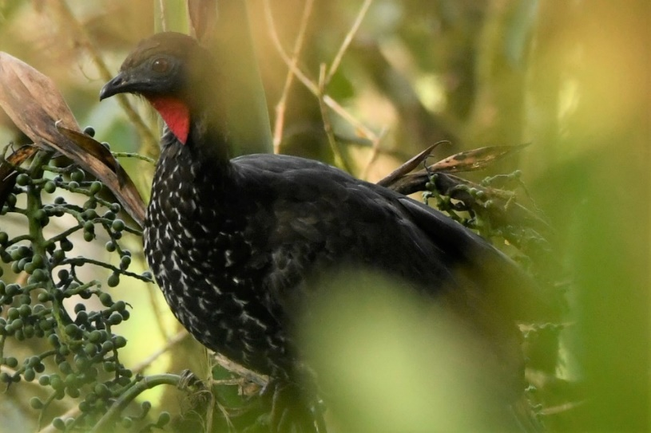
Crested guan, Penelope purpurascens 1 shy and difficult to obeserve in middle level of forest, PAZ (photo – 22 Nov. 2018 Callyn Yorke
New World quail
Order: Galliformes Family: Odontophoridae
The New World quails are small, plump terrestrial birds only distantly related to the quails of the Old World, but named for their similar appearance and habits. Six species have been recorded in Ecuador.
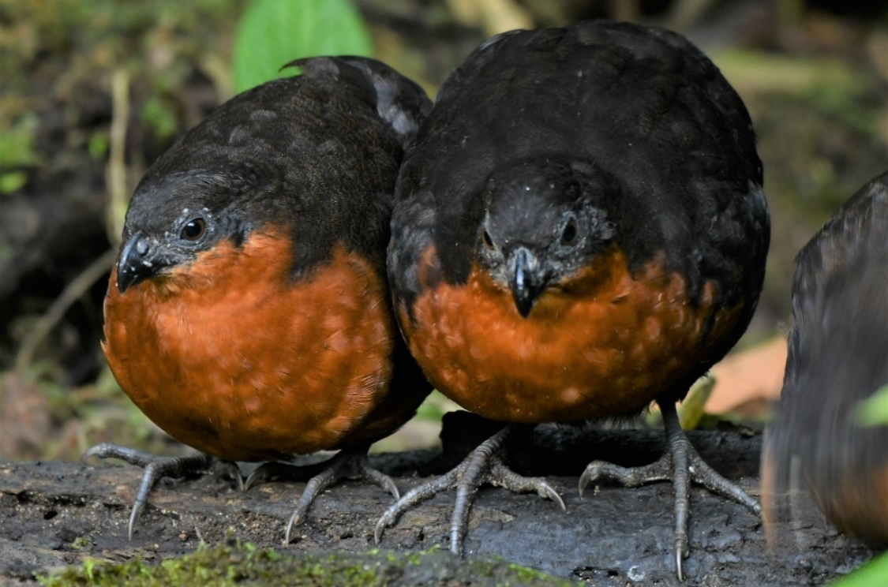Dark-backed wood-quail, Odontophorus melanonotus 3 gregarious, relatively tame from being fed PAZ (photo – 22 Nov. 2018 Callyn Yorke)

Pigeons and doves
Order: Columbiformes Family: Columbidae
Pigeons and doves are stout-bodied birds with short necks and short slender bills with a fleshy cere. Twenty-eight species have been recorded in Ecuador.
Rock pigeon, Columba livia UBQ in and around settlements
Band-tailed pigeon, Patagioenas fasciata 10 NM; 1 TAN
Ruddy pigeon, Patagioenas subvinacea 1 RS
White-tipped dove, Leptotila verreauxi 1 TAN

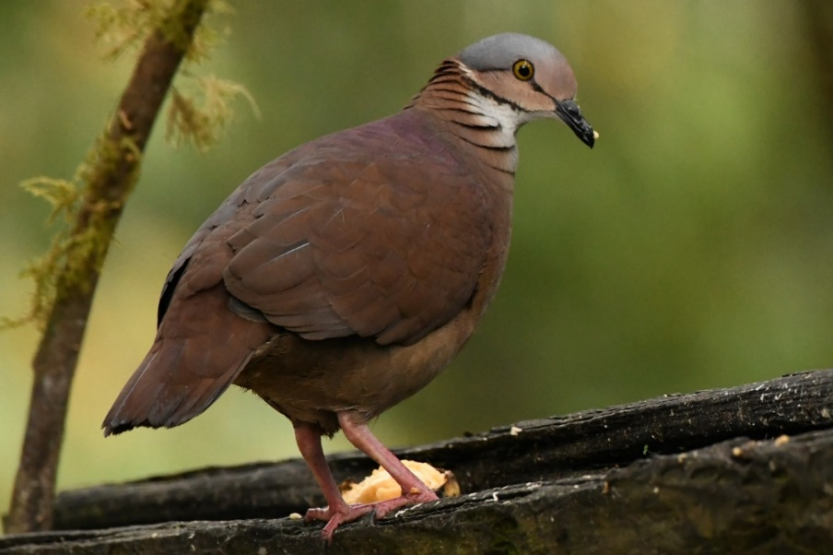
White-throated quail-dove, Zentrygon frenata 2 usually paired; on forest floor around lodge and at fruit trough briefly in early morning, TAN (photo- 23 Nov. 2018 Callyn Yorke)
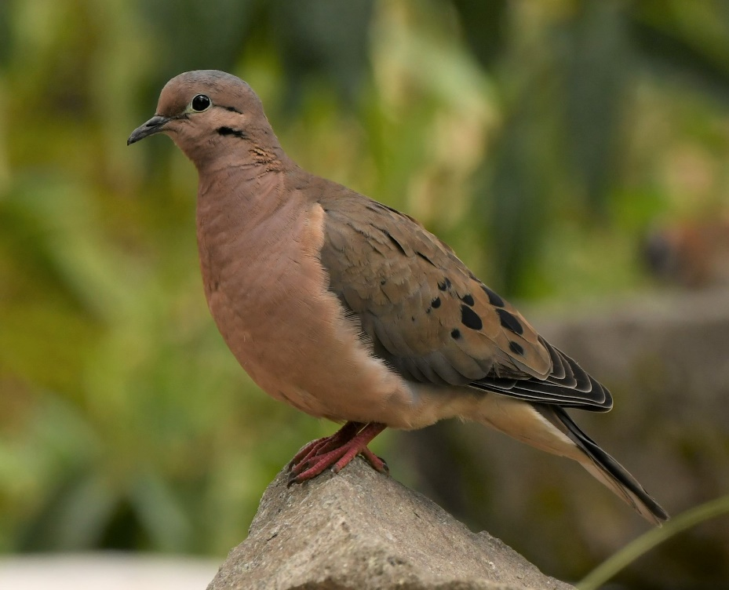
Eared dove, Zenaida auriculata 5 common around settlements, UBQ (photo – 15 Nov. 2018 Callyn Yorke)
Common ground dove, Columbina passerina 2 JNP

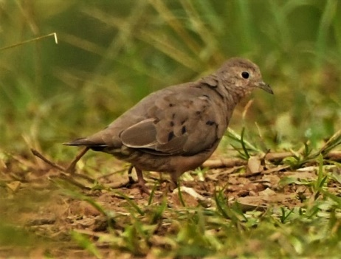
Ecuadorian ground dove, Columbina buckleyi 1 RS (photo- 21 Nov. 2018 Callyn Yorke)

Cuckoos
Order: Cuculiformes Family: Cuculidae
Cuculidae includes cuckoos, roadrunners, and anis. These are birds of variable size with slender bodies, long tails, and strong legs. Eighteen species have been recorded in Ecuador.
Smooth-billed ani, Crotophaga ani 2 RS

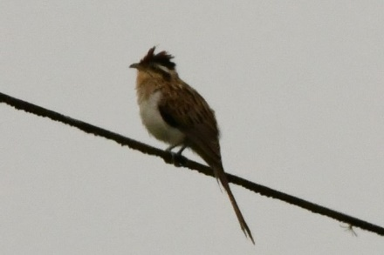
Striped cuckoo, Tapera naevia 1 on utility wire over grassy field, RS (photo –21 Nov. 2018 Callyn Yorke)
Squirrel cuckoo, Piaya cayana 1 subcanopy around moth trap, TAN

Nightjars and allies
Order: Caprimulgiformes Family: Caprimulgidae
Nightjars are medium-sized nocturnal birds which usually nest on the ground. They have long wings, short legs, and very short bills. Most have small feet, of little use for walking, and long pointed wings. Their soft plumage is camouflaged to resemble bark or leaves. Nineteen species have been recorded in Ecuador.
- Lyre-tailed nightjar, Uropsalis lyra 1 resting on lower roof of lodge after dark, TAN

Swifts
Order: Apodiformes Family: Apodidae
Swifts are small birds which spend the majority of their lives flying. These birds have very short legs and never settle voluntarily on the ground, perching instead only on vertical surfaces. Many swifts have long swept-back wings which resemble a crescent or boomerang. Fourteen species have been recorded in Ecuador.
White-chested swift, Cypseloides lemosi 2 flying 50-100m over forest, TAN
Chestnut-collared swift, Streptoprocne rutila 1 flying 50m over forest, PAZ
White-collared swift, Streptoprocne zonaris 3 SJM

Hummingbirds
Order: Apodiformes Family: Trochilidae
Hummingbirds are small birds capable of hovering in mid-air due to the rapid flapping of their wings. They are the only birds that can fly backwards. Approximately one hundred thirty-two species have been recorded in Ecuador.

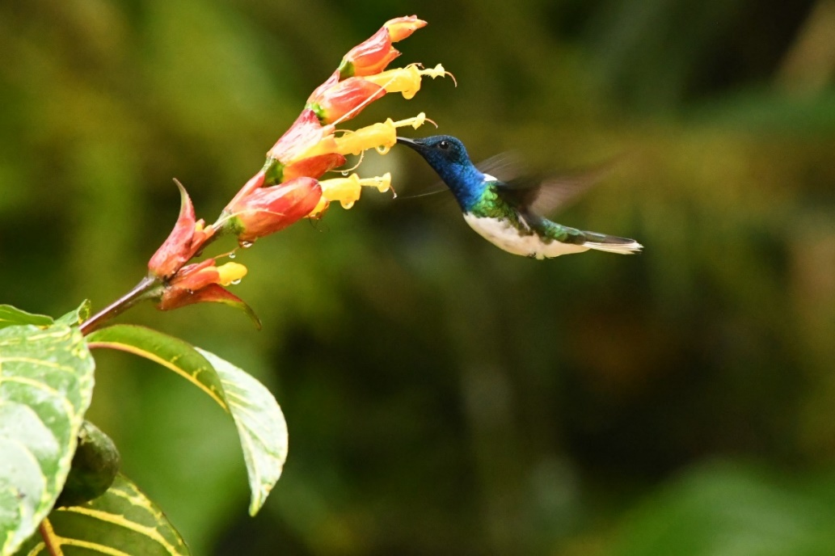
White-necked jacobin, Florisuga mellivora 5 gregariou; persistent around flower feeding station, TAN; SJM (photo-20 November 2018 SJM Callyn Yorke)

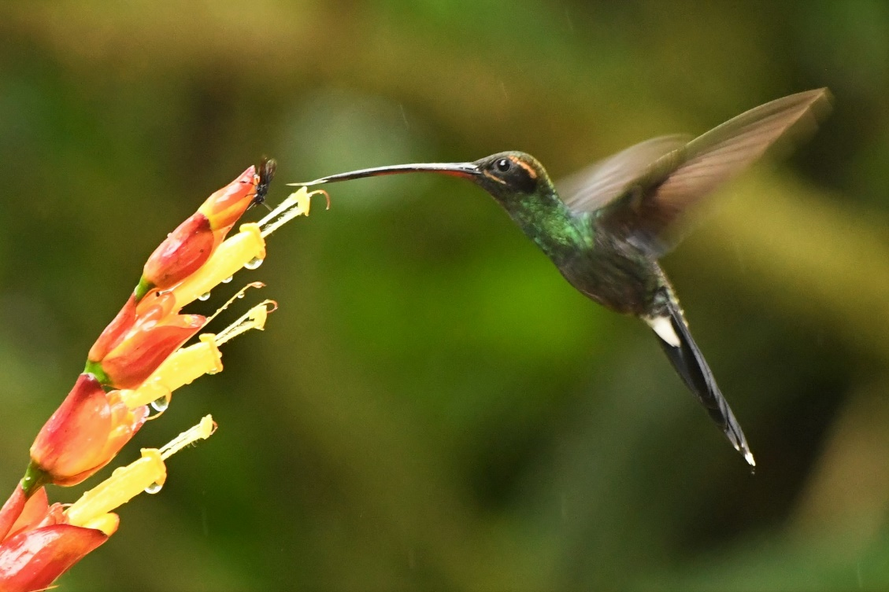
White-whiskered hermit, Phaethornis yaruqui 1 at flower feeding station SJM (photo- 20 Nov. 2018 Callyn Yorke)

Tawny-bellied hermit, Phaethornis syrmatophorus 1 at feeder, TA
Green violetear, Colibri thalassinus 2 trees and shrubs around lodge, TAN

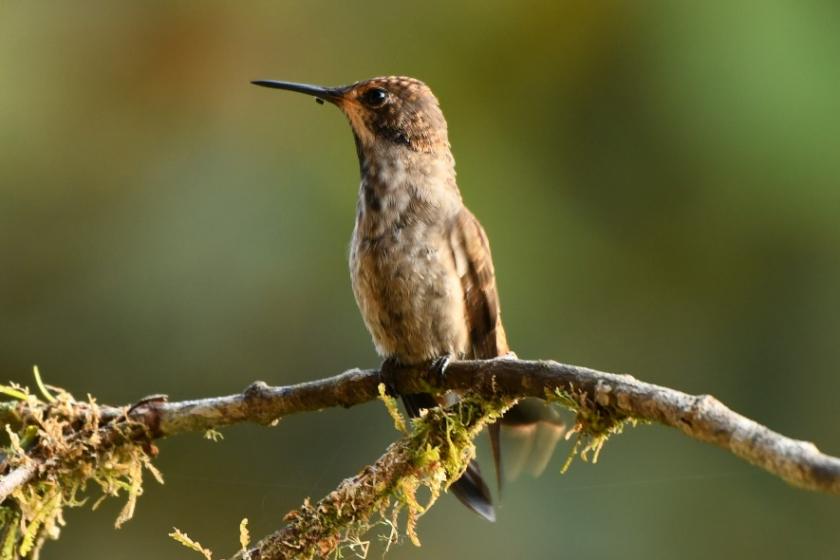
Brown violetear (Colibri delphinea) 1 around feeders, TAN (photo- 18 Nov. 2018 Callyn Yorke)
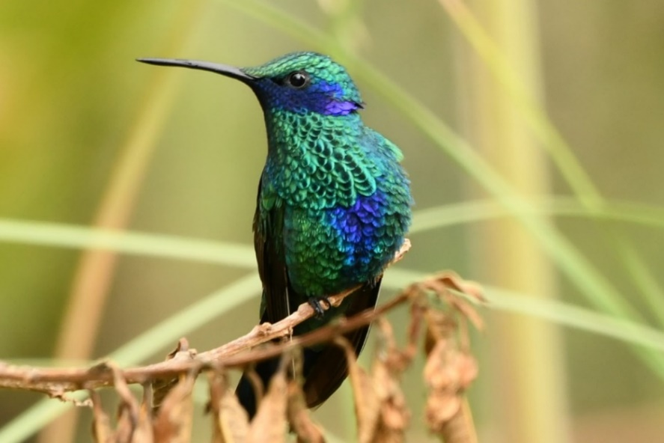Sparkling violetear, Colibri coruscans 3 around feeders, SJQ (photo 15 Nov. 2018 Callyn Yorke)

Green thorntail, Discosura conversii 1 roadside trees RS

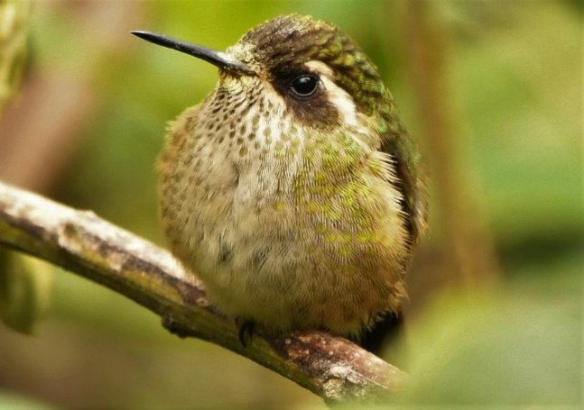
Speckled hummingbird, Adelomyia melanogenys 1 roadside scrub, YAN (photo- 17 Nov. 2018 Callyn Yorke)

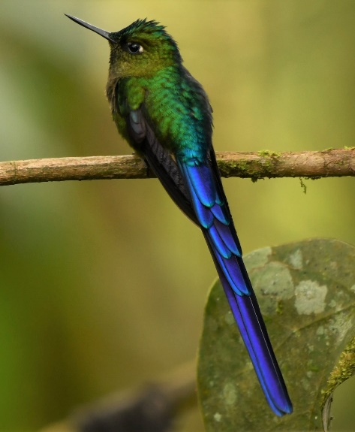
Violet-tailed sylph, Aglaiocercus coelestis 2 around feeders, TAN (photo – 23 Nov, 2018 Callyn Yorke)

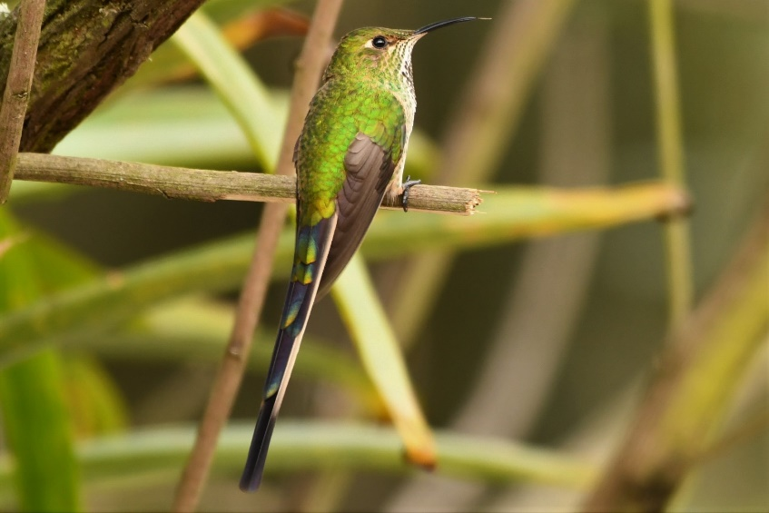
Black-tailed trainbearer, Lesbia victoriae 2 around feeders, SJQ (photo- 15 Nov. 2018 Callyn Yorke)

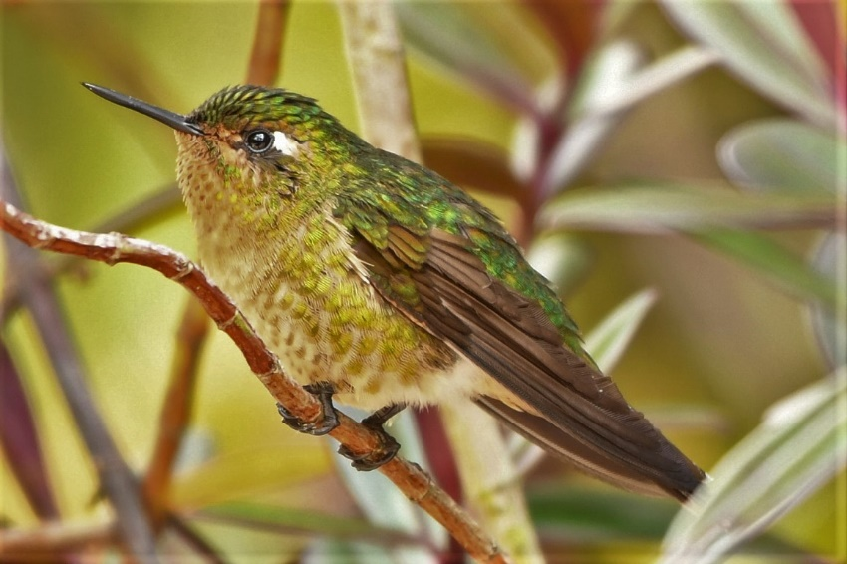
Tyrian metaltail, Metallura tyrianthina 2 around feeders, SJQ (photo- 15 Nov. 2018 Callyn Yorke)

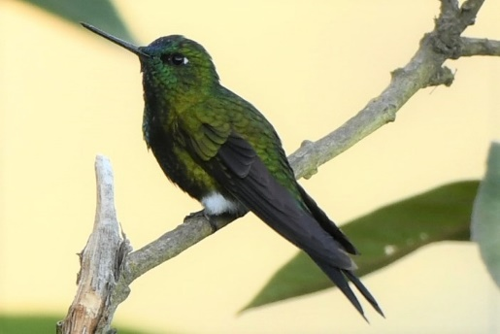
Sapphire-vented puffleg, Eriocnemis luciani 1 roadside scrub, YAN (photo- 17 Nov. 2018 Callyn Yorke)

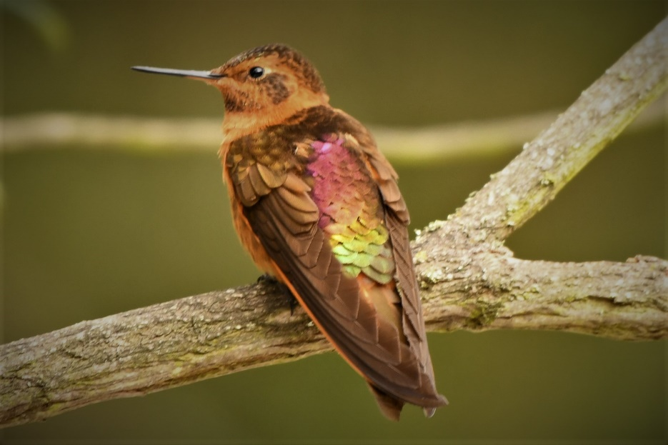
Shining sunbeam, Aglaeactis cupripennis 4 gregarious at feeders, SJQ (photo – 15 November 2018 Callyn Yorke)

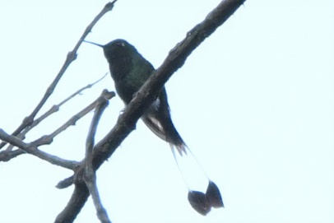
Booted Raquet-tail, Ocreatus underwoodii, 1 SJM (photo- 20 Nov. 2018, Callyn Yorke)

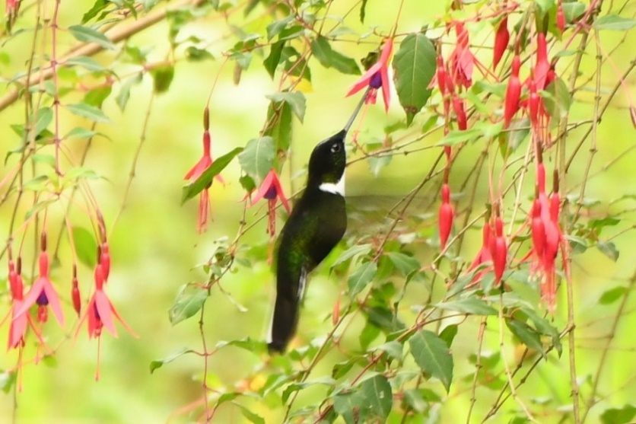
Collared Inca, Coeligena torquata 1 feeding on roadside fuscia flowers, NM (photo – 17 November 2018 Callyn Yorke)

Buff-winged starfrontlet, Coeligena lutetiae 1 roadside scrub, YAN

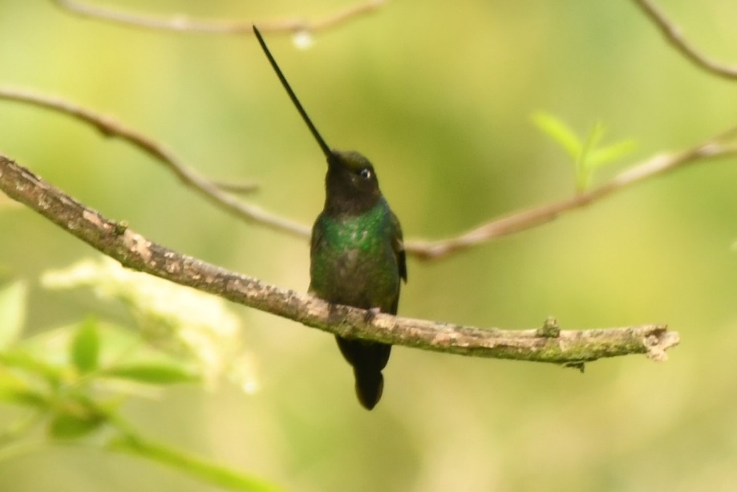
Sword-billed hummingbird, Ensifera ensifera 2 garden trees, SJQ (photo 16 Nov. 2018 Callyn Yorke)

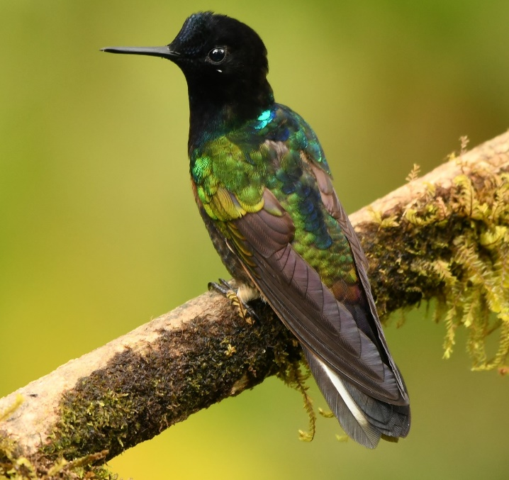
Velvet-purple coronet, Boissonneaua jardini 1 STA (photo- 19 Nov. 2018 Callyn Yorke)

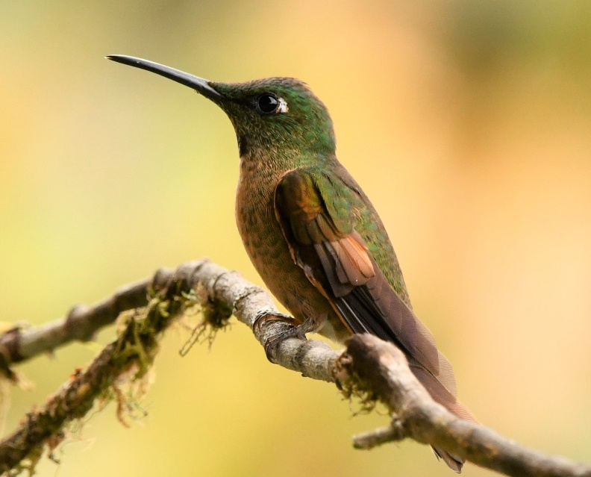
Fawn-breasted brilliant, Heliodoxa rubinoides 3 around feeders, TAN (photo- 23 Nov. 2018 Callyn Yorke)

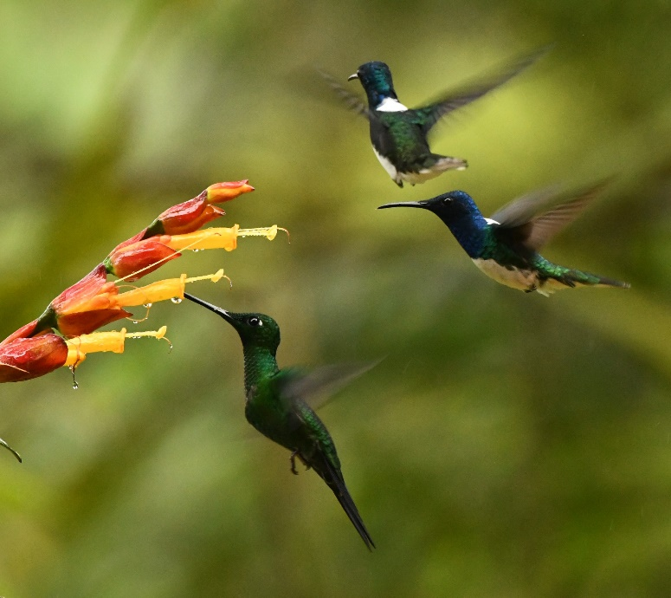
Green-crowned brilliant, Heliodoxa jacula 1 at flower feeders, SJM (photo – with WNJA, 20 Nov. 2018 Callyn Yorke)
Empress brilliant, Heliodoxa imperatrix 1 around flowers in garden, SJM
Giant hummingbird, Patagona gigas 1 cactus scrub, JNP

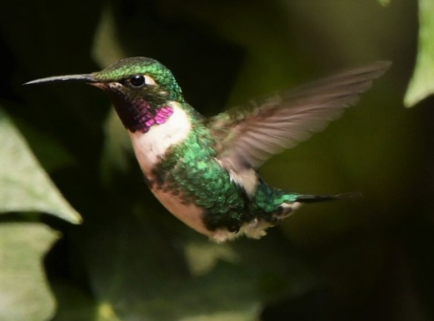
White-bellied woodstar, Chaetocercus mulsant 5 gregarious at feeders, SJQ (photo - 15 Nov. 2018 Callyn Yorke)

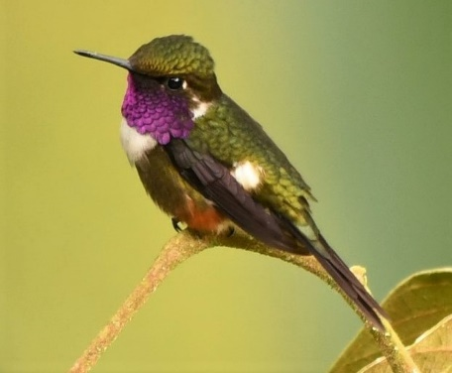
Purple-throated woodstar, Calliphlox mitchellii 1 trailside scrub, JNP; TAN (photo – 18 Nov. 2018 TAN Callyn Yorke)
Western emerald, Chlorostilbon melanorhynchus 2 outer branches of small trees around lodge, TAN
Crowned woodnymph, Thalurania colombica 3 gregarious at edge of forest, SJM

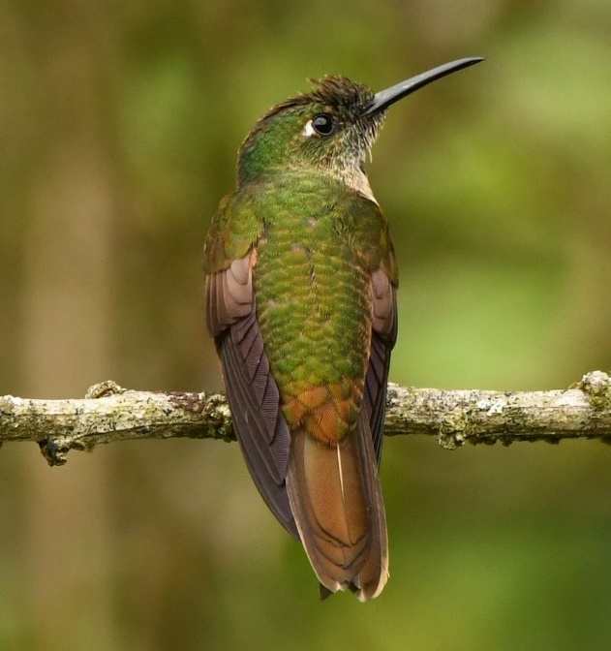
Rufous-tailed hummingbird, Amazilia tzacatl 1 in garden trees, TAN (photo- 23 Nov. 2018 Callyn Yorke)

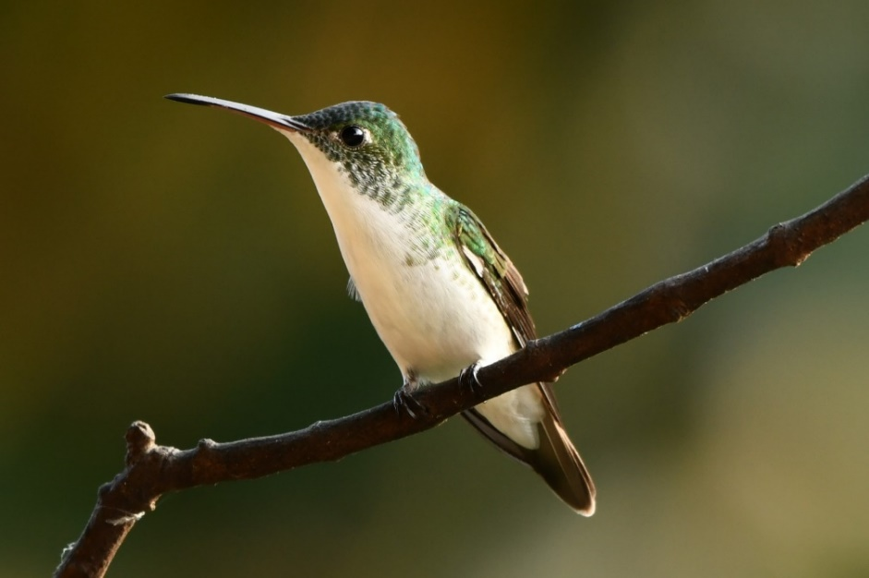
Andean emerald, Amazilia franciae 3 scrub at edge of open field, TAN (photo- 18 Nov. 2018 Callyn Yorke)

Herons, egrets, and bitterns
Order: Pelecaniformes Family: Ardeidae
The family Ardeidae contains the bitterns, herons, and egrets. Herons and egrets are medium to large wading birds with long necks and legs. Bitterns tend to be shorter-necked and more wary. Members of Ardeidae fly with their necks retracted, unlike other long-necked birds such as storks, ibises, and spoonbills. Twenty-two species have been recorded in Ecuador.
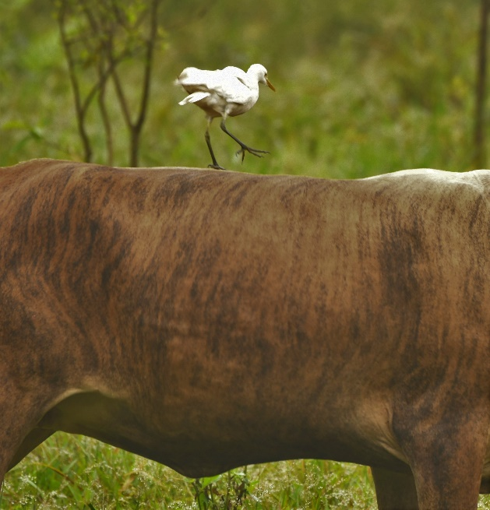
Cattle egret, Bubulcus ibis 2 roadside pasture, RS (photo- 21 Nov. 2018 Callyn Yorke)
Snowy Egret, Egretta thula 1 edge of water basin, AWC

New World vultures
Order: Cathartiformes Family: Cathartidae
The New World vultures are not closely related to Old World vultures, but superficially resemble them because of convergent evolution. Like the Old World vultures, they are scavengers. However, unlike Old World vultures, which find carcasses by sight, New World vultures have a good sense of smell with which they locate carrion. Six species have been recorded in Ecuador.
Black vulture, Coragyps atratus 4 UBQ
Turkey vulture, Cathartes aura 2 UBQ

Hawks, eagles, and kites
Order: Accipitriformes Family: Accipitridae
Accipitridae is a family of birds of prey, which includes hawks, eagles, kites, harriers, and Old World vultures. These birds have powerful hooked beaks for tearing flesh from their prey, strong legs, powerful talons, and keen eyesight. Forty-eight species have been recorded in Ecuador.
Hook-billed kite, Chondrohierax uncinatus 1 RS
Swallow-tailed kite, Elanoides forficatus 1 RS
Roadside hawk, Rupornis magnirostris 2 UBQ
Harris's hawk, Parabuteo unicinctus 1 JNP
Variable hawk, Geranoaetus polyosoma 1 SJQ
Black-chested buzzard-eagle, Geranoaetus melanoleucus 1 YAN
Broad-winged hawk, Buteo platypterus 1 TAN

Owls
Order: Strigiformes Family: Strigidae
The typical owls are small to large solitary nocturnal birds of prey. They have large forward-facing eyes and ears, a hawk-like beak, and a conspicuous circle of feathers around each eye called a facial disk. Twenty-seven species have been recorded in Ecuador.
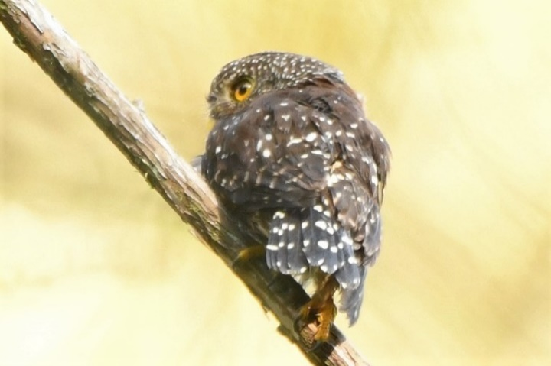
Andean pygmy-owl, Glaucidium jardinii 1 PAZ (photo- 22 Nov. 2018 Callyn Yorke)
Burrowing owl, Athene cunicularia 1 YAN-NM

Trogons
Order: Trogoniformes Family: Trogonidae
The family Trogonidae includes trogons and quetzals. Found in tropical woodlands worldwide, they feed on insects and fruit, and their broad bills and weak legs reflect their diet and arboreal habits. Although their flight is fast, they are reluctant to fly any distance. Trogons have soft, often colorful, feathers with distinctive male and female plumage. Fifteen species have been recorded in Ecuador.
Golden-headed quetzal, Pharomachrus auriceps 1 TAN
Crested quetzal, Pharomachrus antisianus 1 vocal (unseen) TAN

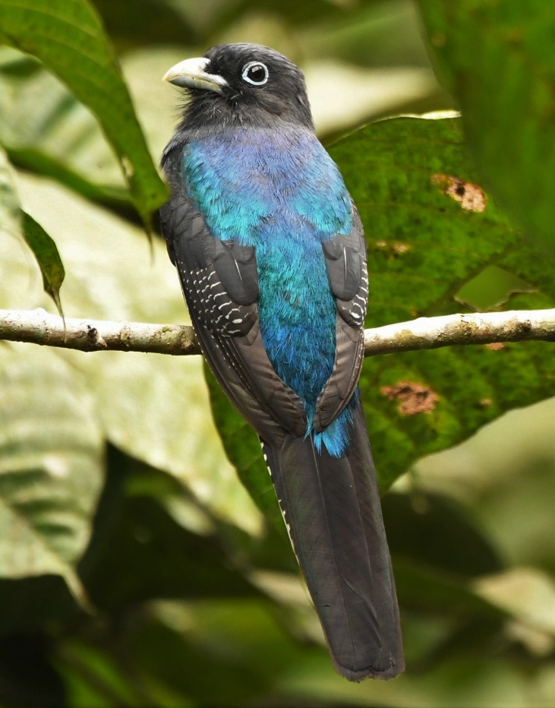
White-tailed trogon, Trogon chionurus 2 (m,f) RS (photo – 21 Nov. 2018 Callyn Yorke)
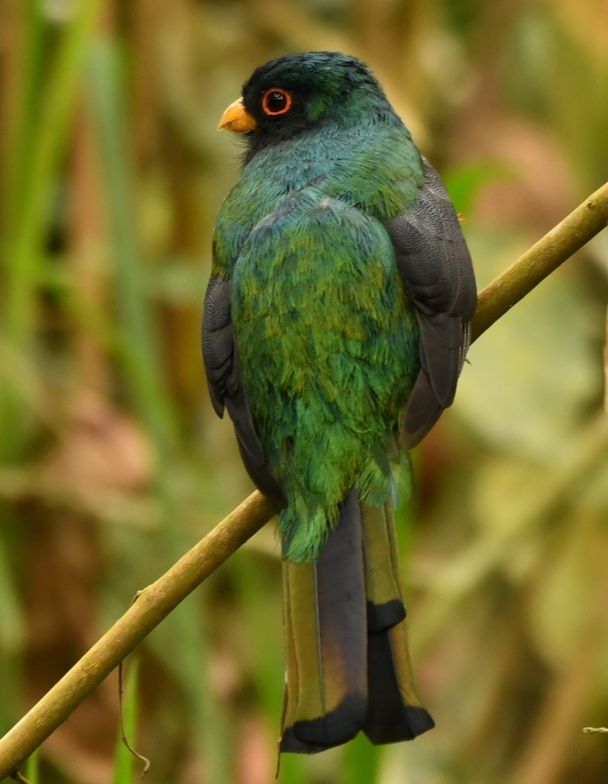
Masked trogon, Trogon personatus 2 (m,f) at moth trap, TAN (photo – 20 Nov. 2018 Callyn Yorke)
Choco Trogon, Trogon comptus 1 RS

Kingfishers
Order: Coraciiformes Family: Alcedinidae
Kingfishers are medium-sized birds with large heads, long pointed bills, short legs, and stubby tails. Six species have been recorded in Ecuador.
Green kingfisher, Chloroceryle americana 1 PAZ

Motmots
Order: Coraciiformes Family: Momotidae
The motmots have colorful plumage and long, graduated tails which they display by waggling back and forth. In most of the species, the barbs near the ends of the two longest (central) tail feathers are weak and fall off, leaving a length of bare shaft and creating a racket-shaped tail. Five species have been recorded in Ecuador.
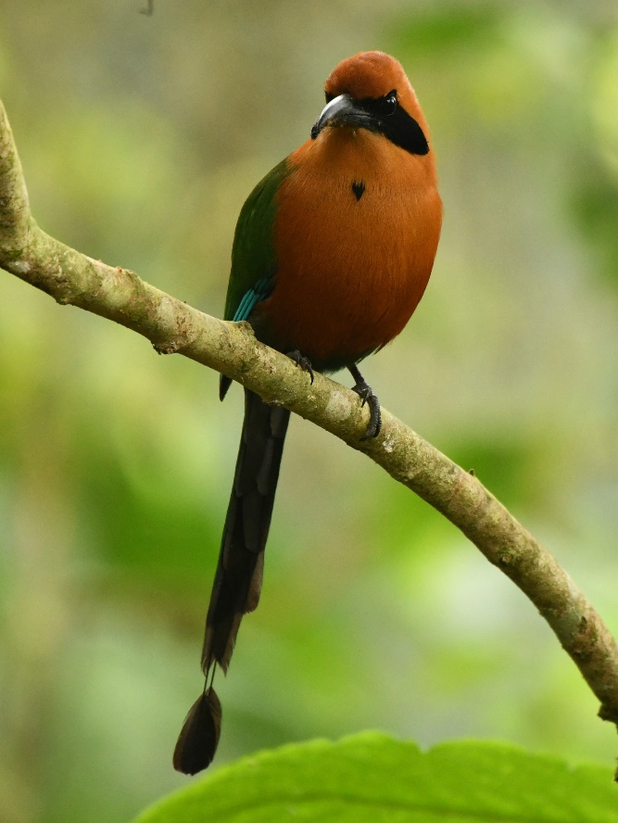
Rufous motmot, Baryphthengus martii 1 SJM (photo – 20 Nov. 2018 Callyn Yorke)

Puffbirds
Order: Galbuliformes Family: Bucconidae
The puffbirds are related to the jacamars and have the same range, but lack the iridescent colors of that family. They are mainly brown, rufous, or gray, with large heads and flattened bills with hooked tips. The loose abundant plumage and short tails makes them look stout and puffy, giving rise to the English common name of the family. Twenty species have been recorded in Ecuador.

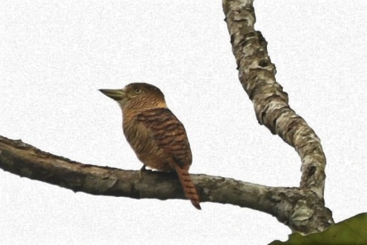
Barred puffbird, Nystalus radiatus 1 RS (photo- 21 Nov. 2018 Callyn Yorke)

New World barbets
Order: Piciformes Family: Capitonidae
The barbets are plump birds, with short necks and large heads. They get their name from the bristles which fringe their heavy bills. Most species are brightly colored. Six species have been recorded in Ecuador.
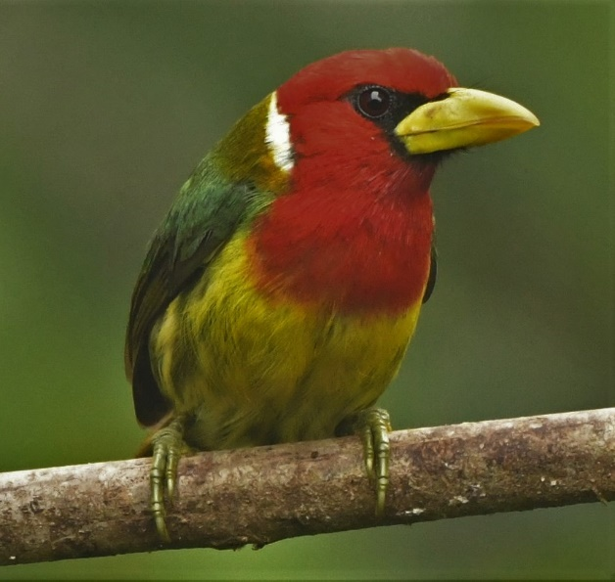
Red-headed barbet, Eubucco bourcierii 2 SJM (photo- male 19 Nov. 2018 Callyn Yorke)

Toucan-barbets
Order: Piciformes Family: Semnornithidae
The toucan-barbets are birds of montane forests in the Neotropics. They are highly social and non-migratory.
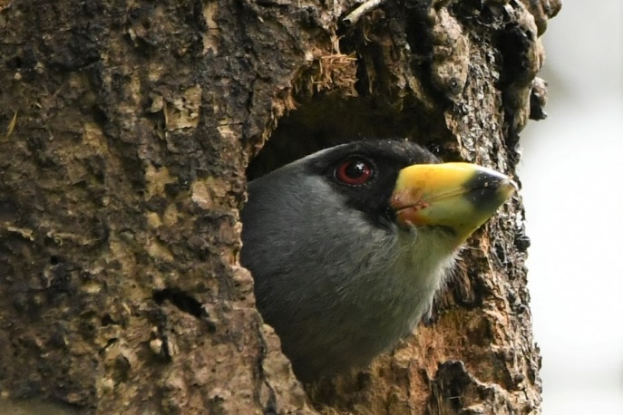
Toucan barbet, Semnornis ramphastinus 1 in nest cavity, PAZ; 2 TAN (photo – 22 Nov. 2018 PAZ, Callyn Yorke)

Toucans
Order: Piciformes Family: Ramphastidae
Toucans are near passerine birds from the Neotropics. They are brightly marked and have enormous, colorful bills which in some species amount to half their body length. Nineteen species have been recorded in Ecuador.
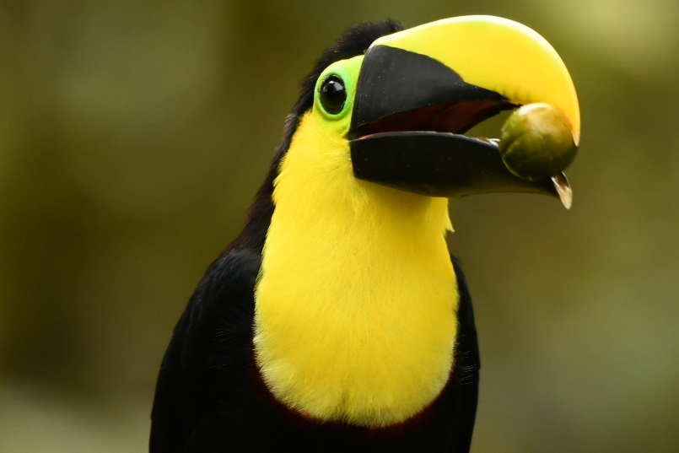
Choco toucan, Ramphastos brevis 3 TAN; 4 SJM (photo- 19 Nov. 2018 SJM, Callyn Yorke)
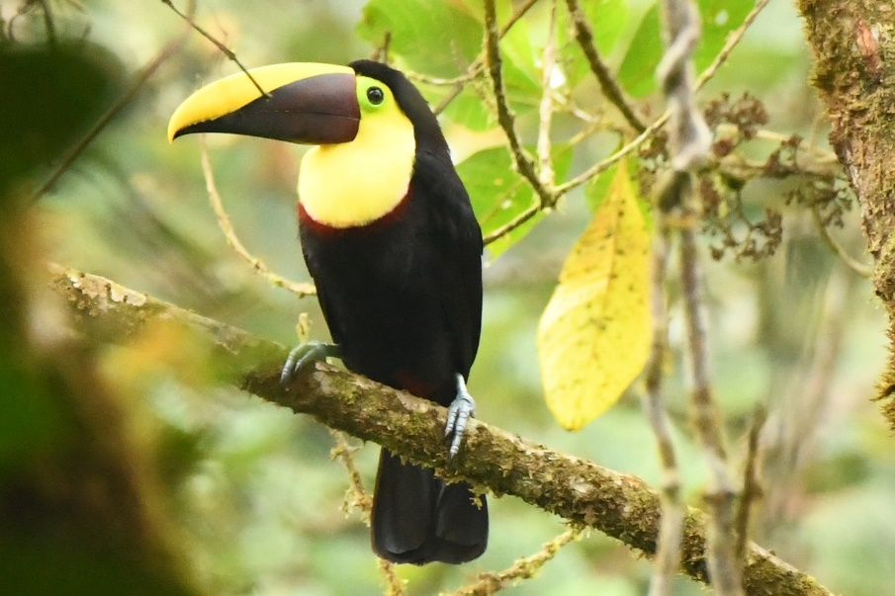
Black-mandibled (Yellow-throated) toucan, Ramphastos ambiguus 2 TAN; 2 SJM (photo- 20 Nov. 2018 SJM Callyn Yorke)

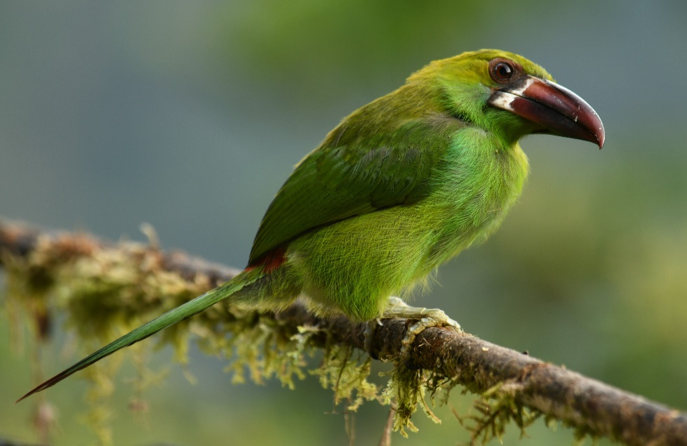
Crimson-rumped toucanet, Aulacorhynchus haematopygus 2 TAN; SJM (photo- 19 Nov. 2018 TAN, Callyn Yorke)

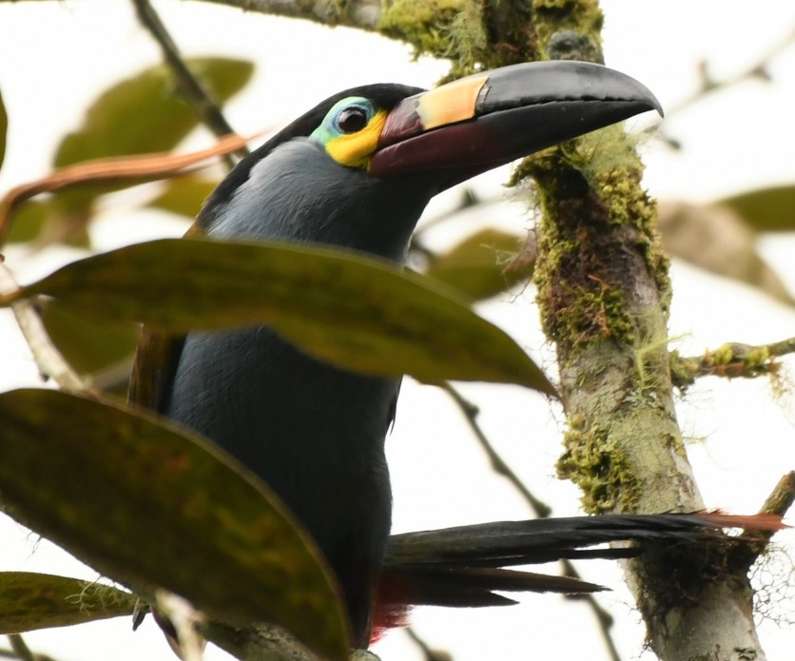
Plate-billed mountain-toucan, Andigena laminirostris 4 gregarious, NM (photo- 17 Nov. 2018 Callyn Yorke)

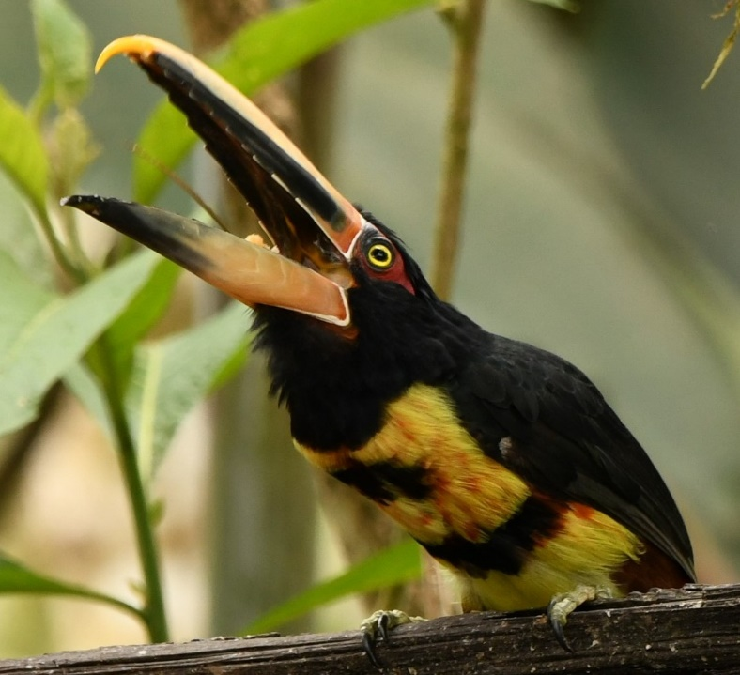
Pale-mandibled aracari, Pteroglossus erythropygius 2 TAN; 4 SJM (photo – 24 Nov. 2018 TAN, Callyn Yorke)

Woodpeckers
Order: Piciformes Family: Picidae
Woodpeckers are small to medium-sized birds with chisel-like beaks, short legs, stiff tails, and long tongues used for capturing insects. Some species have feet with two toes pointing forward and two backward, while several species have only three toes. Many woodpeckers have the habit of tapping noisily on tree trunks with their beaks. Thirty-four species have been recorded in Ecuador.
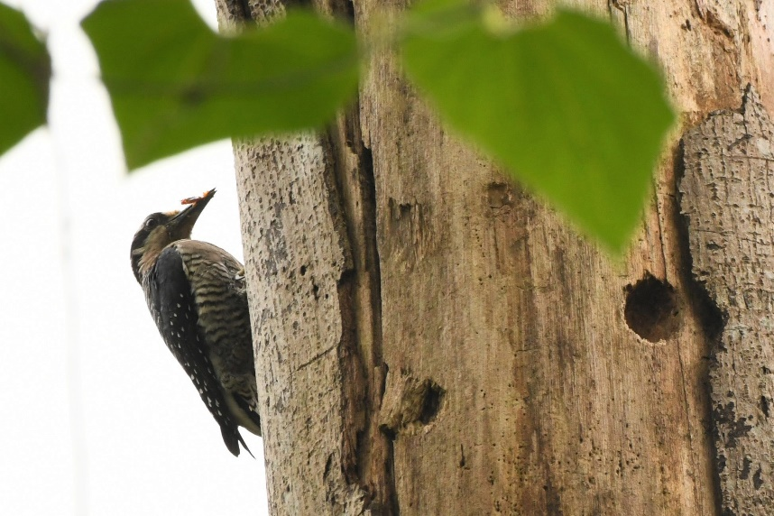
Black-cheeked woodpecker, Melanerpes pucherani 2 RS (photo- 21 Nov. 2018 Callyn Yorke)
Guayaquil woodpecker, Campephilus gayaquilensis 1 RS

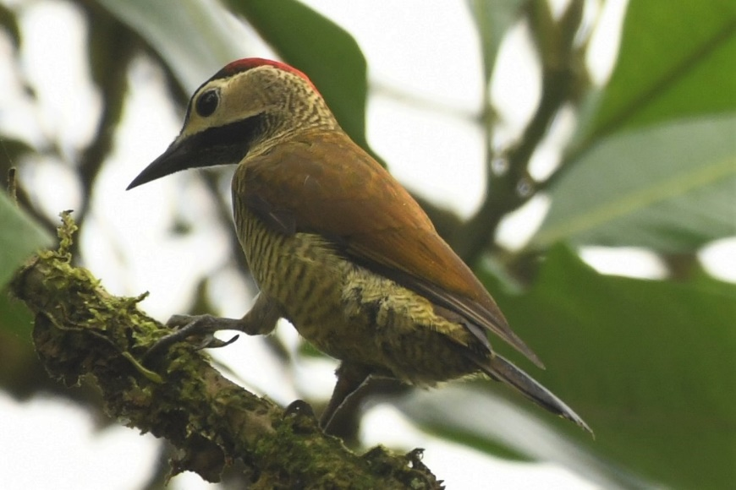Golden-olive woodpecker, Colaptes rubiginosus 1 NM; 1 RS (photo – 21 Nov. 2018 Callyn Yorke)
Crimson-mantled woodpecker, Colaptes rivolii 1 SJQ

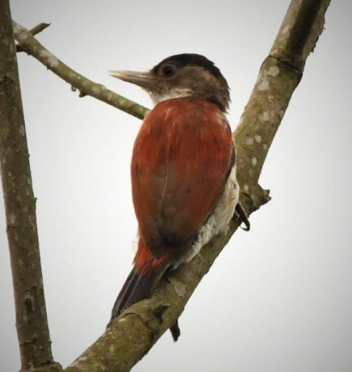
Scarlet-backed Woodpecker, Veniliornis callanotus 1 RS (photo- 21 Nov. 2018 Callyn Yorke)

Falcons and caracaras
Order: Falconiformes Family: Falconidae
Falconidae is a family of diurnal birds of prey. They differ from hawks, eagles, and kites in that they kill with their beaks instead of their talons. Nineteen species have been recorded in Ecuador.
American kestrel, Falco sparverius 2 YAN

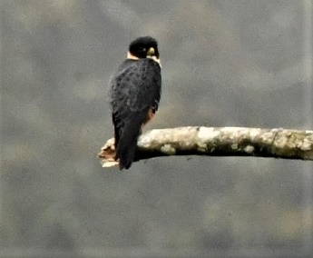
Bat falcon, Falco rufigularis 1 TAN (photo- 23 Nov. 2018 Callyn Yorke)

New World and African parrots
Order: Psittaciformes Family: Psittacidae
Parrots are small to large birds with a characteristic curved beak. Their upper mandibles have slight mobility in the joint with the skull and they have a generally erect stance. All parrots are zygodactyl, having the four toes on each foot placed two at the front and two to the back. Forty-seven species have been recorded in Ecuador.
Red-billed parrot, Pionus sordidus 7 TAN
Blue-headed parrot, Pionus menstruus 1 vocal (unseen) RS
Pacific parrotlet, Forpus coelestis 2 RS
Maroon-tailed parakeet, Pyrrhura melanura 2 RS

Typical antbirds
Order: Passeriformes Family: Thamnophilidae
The antbirds are a large family of small passerine birds of subtropical and tropical Central and South America. They are forest birds which tend to feed on insects at or near the ground. A sizable minority of them specialize in following columns of army ants to eat small invertebrates that leave their hiding places to flee from the ants. Many species lack bright color, with brown, black, and white being the dominant tones. Ninety-five species have been recorded in Ecuador.
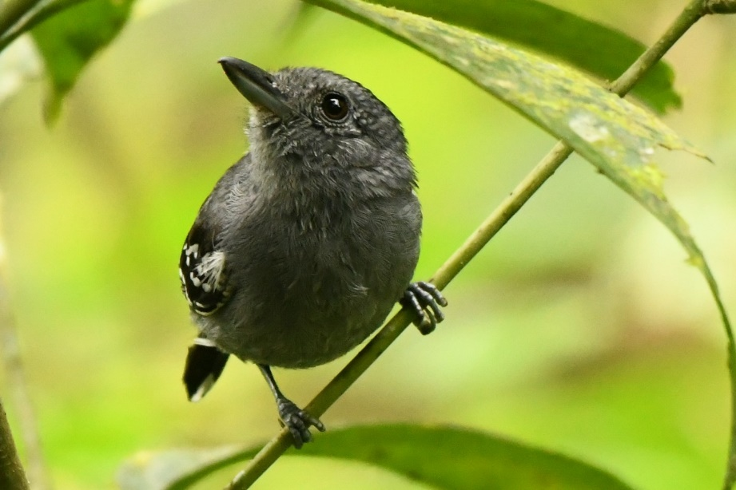
Western slaty antshrike, Thamnophilus atrinucha 1 SJM (photo- 20 Nov. 2018 Callyn Yorke)
Dot-winged antwren, Microrhopias quixensis 1roadside sec. growth SJM-RS
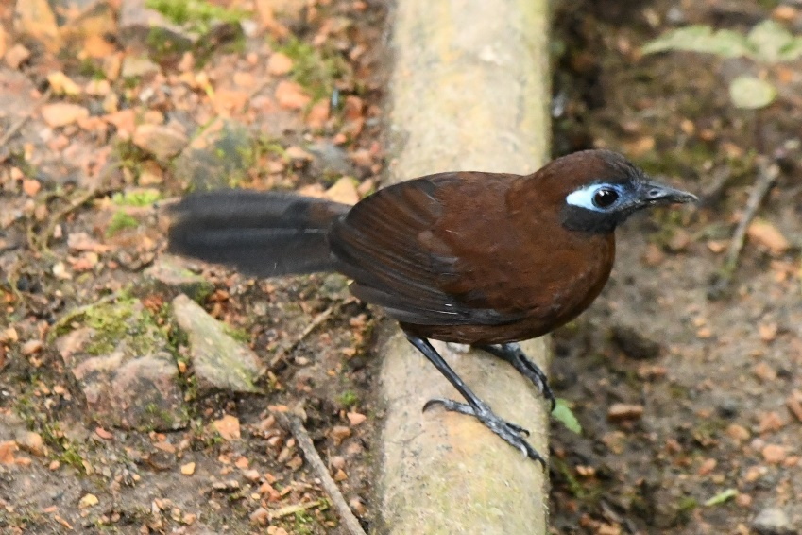
Zeledon's antbird, Hafferia zeledoni 1on forest floor, SJM (photo – 20 Nov. 2018 Callyn Yorke)

Antpittas[edit]
Order: Passeriformes Family: Grallariidae
Antpittas resemble the true pittas with strong, longish legs, very short tails, and stout bills. Twenty-four species have been recorded in Ecuador.
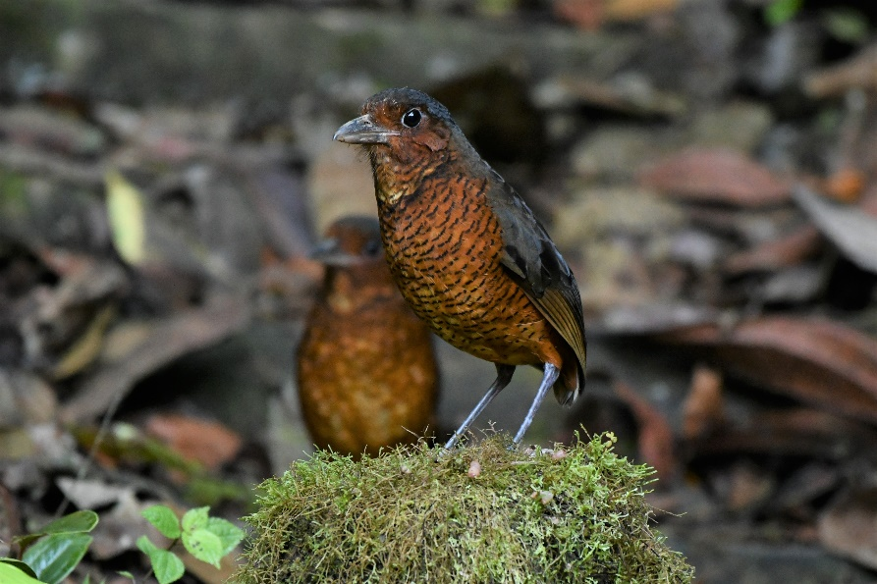
Giant antpitta, Grallaria gigantea 2 a pair called & baited, PAZ (photo- 22 Nov. 2018 Callyn Yorke)
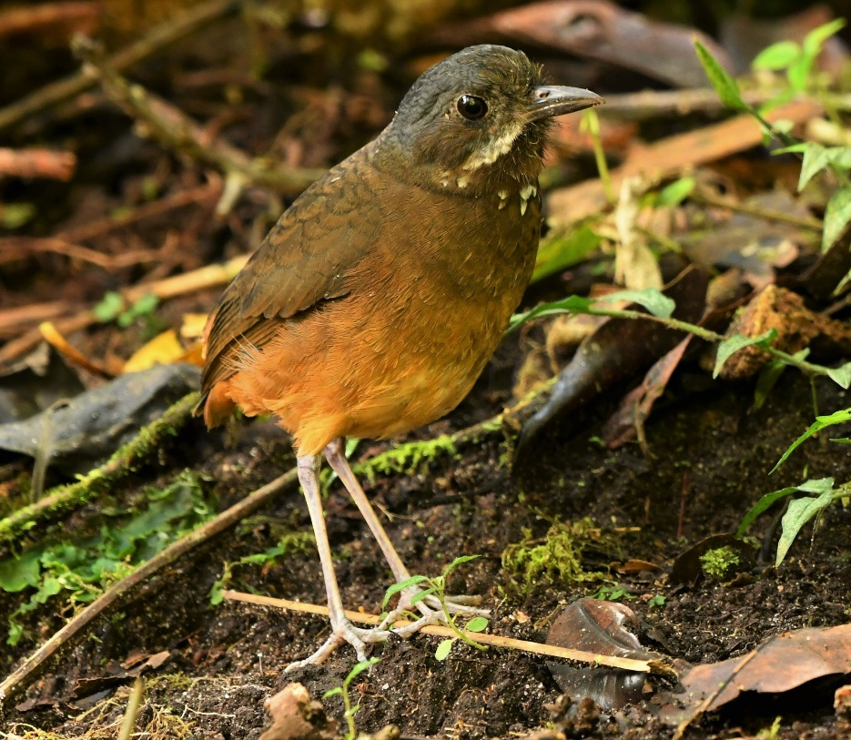
Moustached antpitta, Grallaria alleni 1,called & baited, PAZ (photo- 22 Nov. 2018 Callyn Yorke)

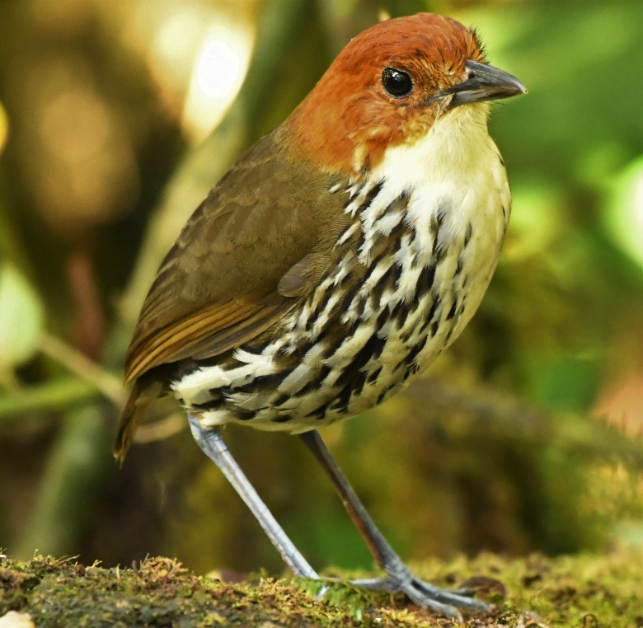
Chestnut-crowned antpitta, Grallaria ruficapilla 1, baited, PAZ (photo- 22 Nov. 2018 Callyn Yorke)
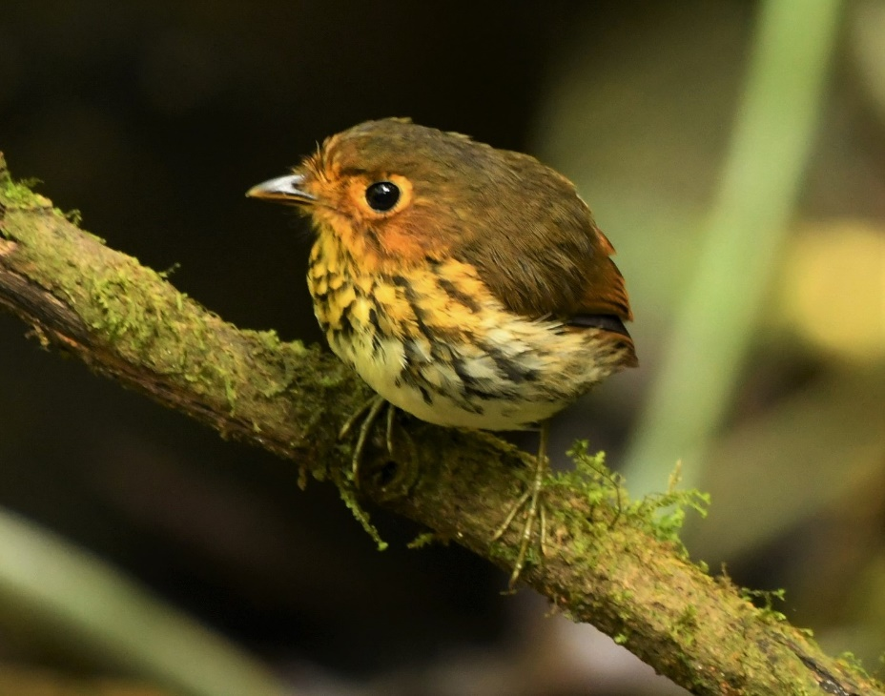
Ochra-breasted antpitta, Grallaricula flavirostris 1 PAZ (photo- 22 Nov. 2018 Callyn Yorke)

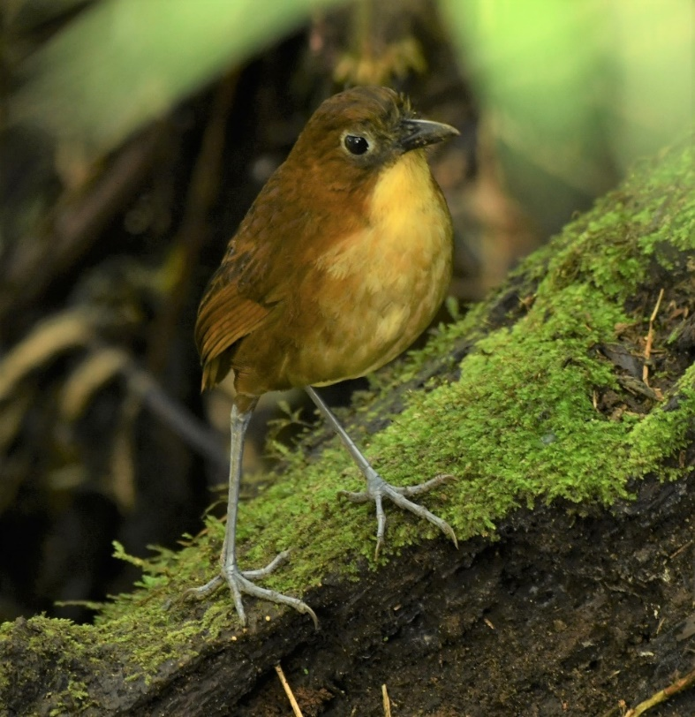
Yellow-breasted antpitta, Grallaria flavotincta 1, baited, PAZ (photo- 22 Nov. 2018 Callyn Yorke)

Tapaculos
Order: Passeriformes Family: Rhinocryptidae
The tapaculos are small suboscine passeriform birds with numerous species in South and Central America. They are terrestrial species that fly only poorly on their short wings. They have strong legs, well-suited to their habitat of grassland or forest undergrowth. The tail is cocked and pointed towards the head. Twelve species have been recorded in Ecuador.
Ocellated tapaculo, Acropternis orthonyx 1 responded to playback, roadside secondary forest, TAN- SJM
Blackish Tapaculo, Scytalopus latrans 1 JNP

Antthrushes
Order: Passeriformes Family: Formicariidae
Antthrushes resemble small rails with strong, longish legs, very short tails, and stout bills. Seven species have been recorded in Ecuador.
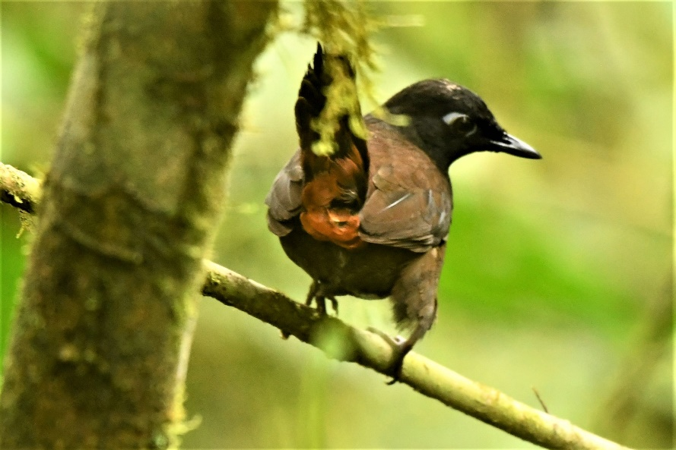
Black-headed antthrush, Formicarius nigricapillus 1 SJM (photo- 20 Nov. 2018 Callyn Yorke)

Ovenbirds and woodcreepers
Order: Passeriformes Family: Furnariidae
Ovenbirds comprise a large family of small sub-oscine passerine bird species found in Central and South America. They are a diverse group of insectivores which gets its name from the elaborate "oven-like" clay nests built by some species, although others build stick nests or nest in tunnels or clefts in rock. The woodcreepers are brownish birds which maintain an upright vertical posture, supported by their stiff tail vanes. They feed mainly on insects taken from tree trunks. One hundred six species have been recorded in Ecuador.

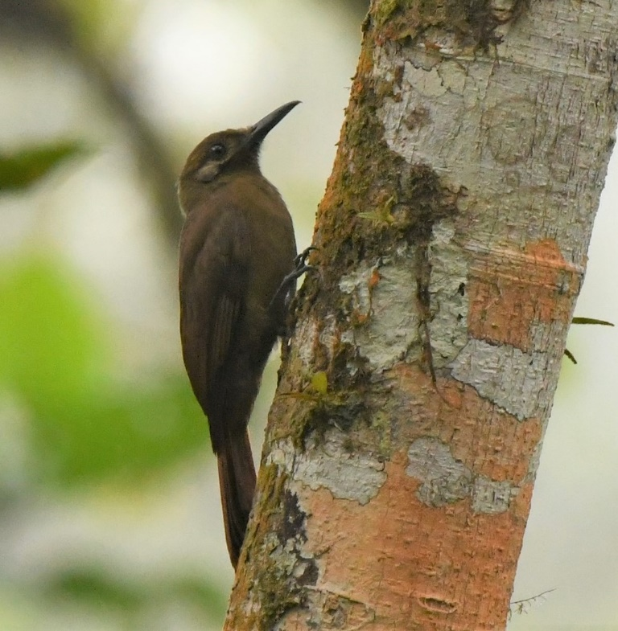
Plain brown Woodcreeper (Dendrocincla fuluginosa) 1 on vertical tree trunk, SJM (photo-
20 Nov. 2018 Callyn Yorke)

Wedge-billed woodcreeper, Glyphorynchus spirurus 1 in eucalyptus, SJQ
Spotted woodcreeper, Xiphorhynchus erythropygius 1 SJM
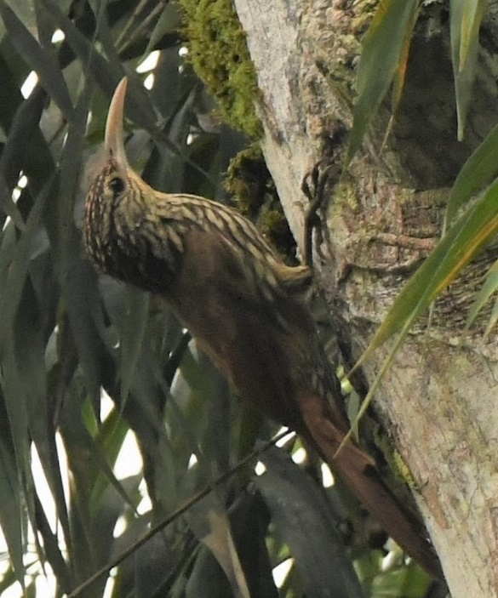
Streak-headed woodcreeper, Lepidocolaptes souleyetii 1 RS (photo 21 Nov. 2018 Callyn Yorke)
Montane woodcreeper, Lepidocolaptes lacrymiger 1 TAN
Scaly-throated foliage-gleaner, Anabacerthia variegaticeps 1 TAN

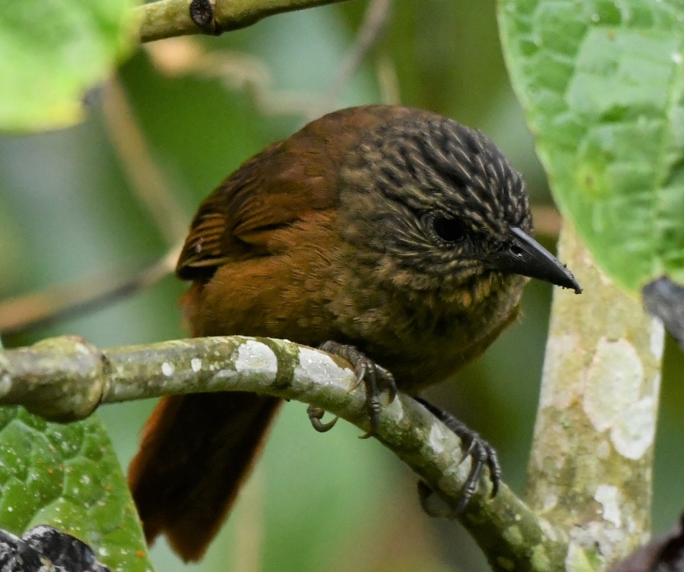Streak-capped treehunter, Thripadectes virgaticeps 1 TAN (photo- 24 Nov. 2018 Callyn Yorke)
Pearled treerunner, Margarornis squamiger 1 moving to and from trees in wooded ravine NM
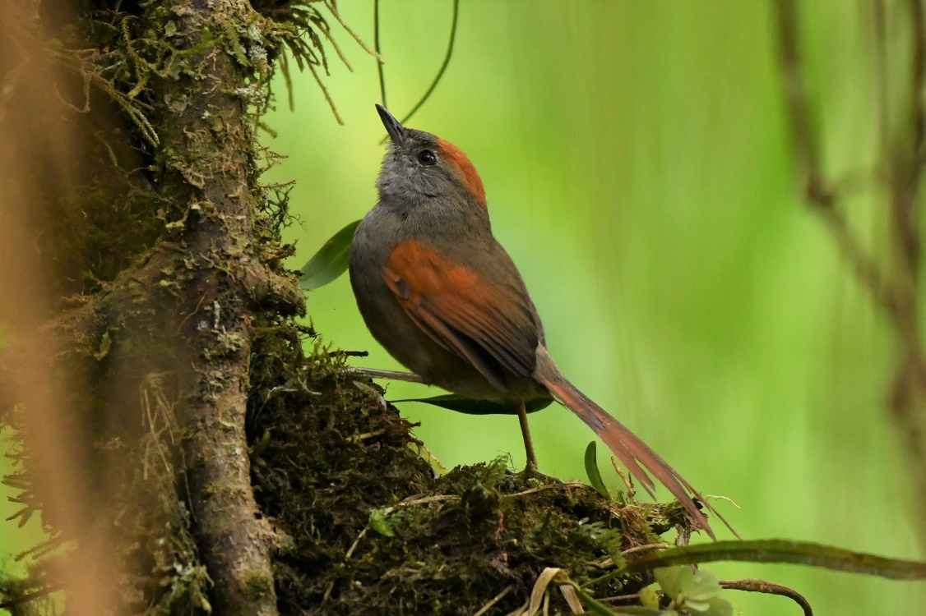Azara's spinetail, Synallaxis azarae 2 TAN (photo- 23 Nov. 2018 Callyn Yorke)
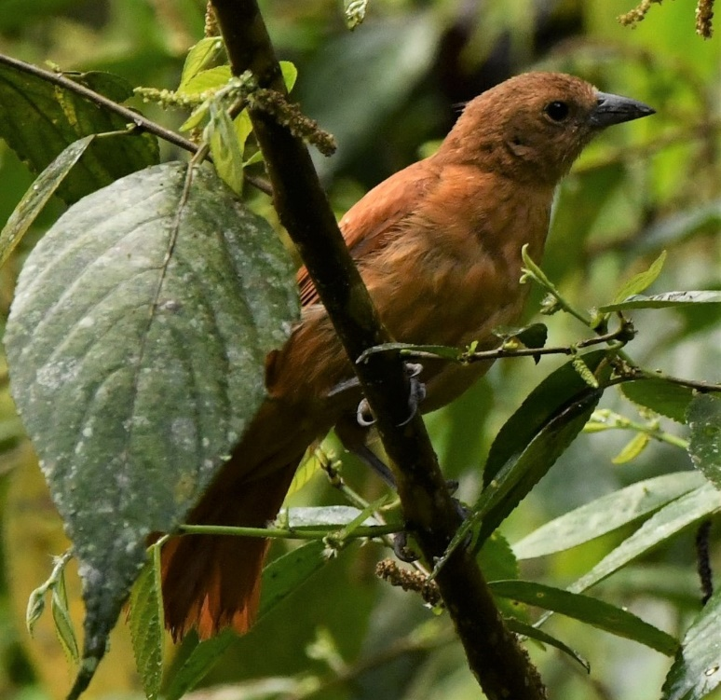
Rufous Spinetail, Synallaxis unirufa 1 TAN (photo- 24 Nov. 2018 Callyn Yorke)
Streaked Tufted-cheek, Pseudocolaptes boissonneautii 1 STA

Tyrant flycatchers
Order: Passeriformes Family: Tyrannidae
Tyrant flycatchers are passerine birds which occur throughout North and South America. They superficially resemble the Old World flycatchers, but are more robust and have stronger bills. They do not have the sophisticated vocal capabilities of the songbirds. Most, but not all, have plain coloring. As the name implies, most are insectivorous. Two hundred one species have been recorded in Ecuador.
Yellow-bellied elaenia, Elaenia flavogaster 1 JNP
White-crested elaenia, Elaenia albiceps 1 SJQ
Sierran elaenia, Elaenia pallatangae 1 TAN
White-tailed tyrannulet, Mecocerculus poecilocercus 1 TAN
White-banded tyrannulet, Mecocerculus stictopterus 1 SJQ

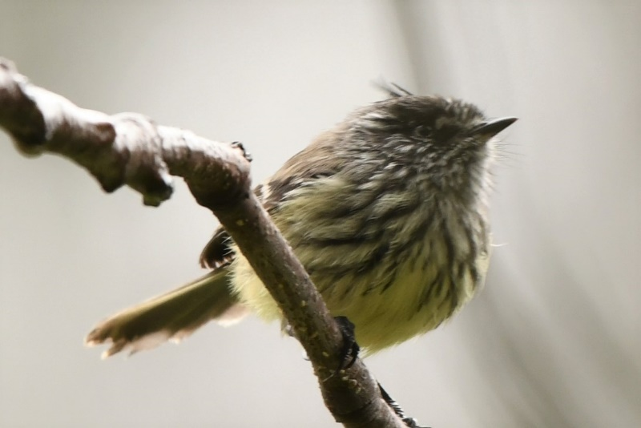
Tufted tit-tyrant, Anairetes parulus 1 SJQ (photo- 16 November 2018 Callyn Yorke)
Choco tyrannulet, Zimmerius albigularis 1 RS
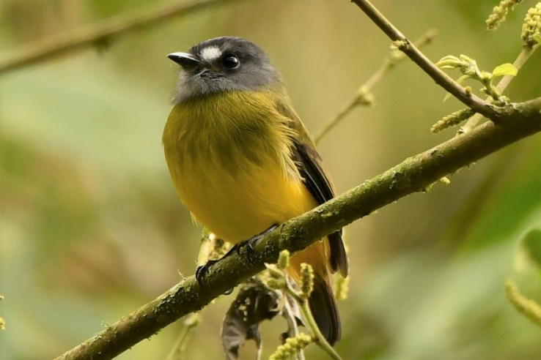
Ornate flycatcher, Myiotriccus ornatus 1 TAN (photo- 18 Nov. 2018 Callyn Yorke)

Flavescent flycatcher, Myiophobus flavicans 1 PAZ
Bran-colored flycatcher, Myiophobus fasciatus 1 RS

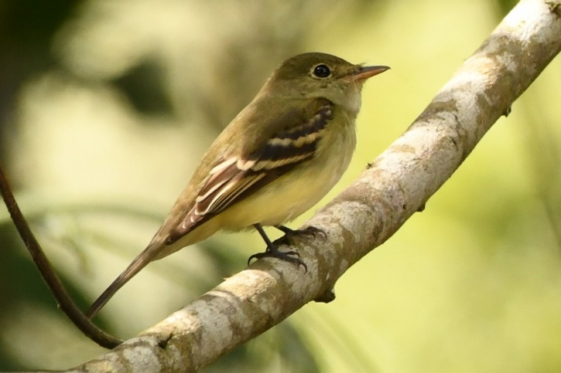
Acadian flycatcher, Empidonax virescens 1 aorund moth trap, TAN (photo- 23 Nov. 2018 Callyn Yorke)

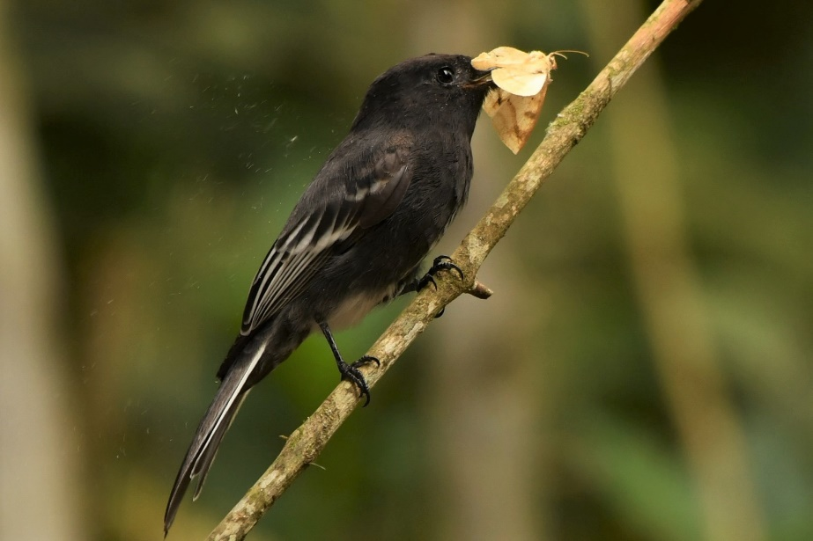
Black phoebe, Sayornis nigricans 1 feeding at moth traap TAN (photo- 18 Nov. 2018 Callyn Yorke)
Vermilion flycatcher, Pyrocephalus rubinus 2 (m,f) JNP

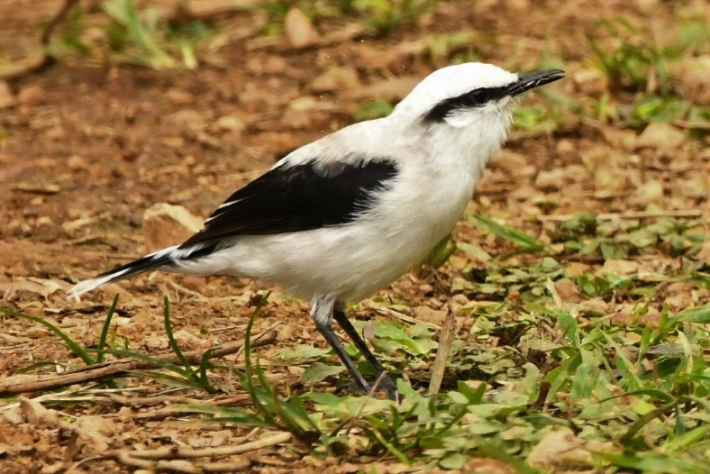
Masked water-tyrant, Fluvicola nengeta 2 a pair staying together on the ground in a wet grassland, RS (photo – 21 Nov. 2018 Callyn Yorke)
Slaty-backed chat-tyrant, Ochthoeca cinnamomeiventris 1 TAN
Rufous-breasted chat-tyrant, Ochthoeca rufipectoralis
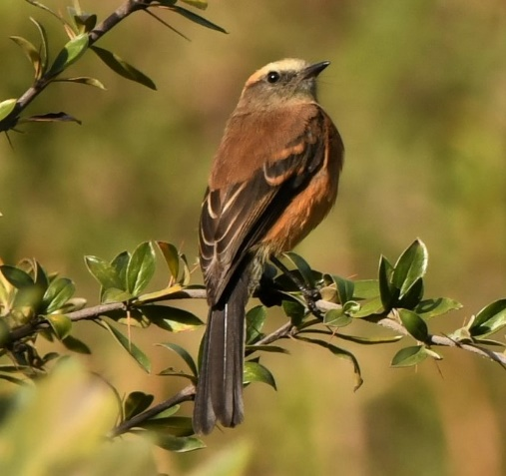
Brown-backed chat-tyrant, Ochthoeca fumicolor 1 YAN (photo – 19 Nov. 2018 Callyn Yorke)
Social flycatcher, Myiozetetes similis 1 TAN
Yellow-throated flycatcher, Conopias parvus 1 RS

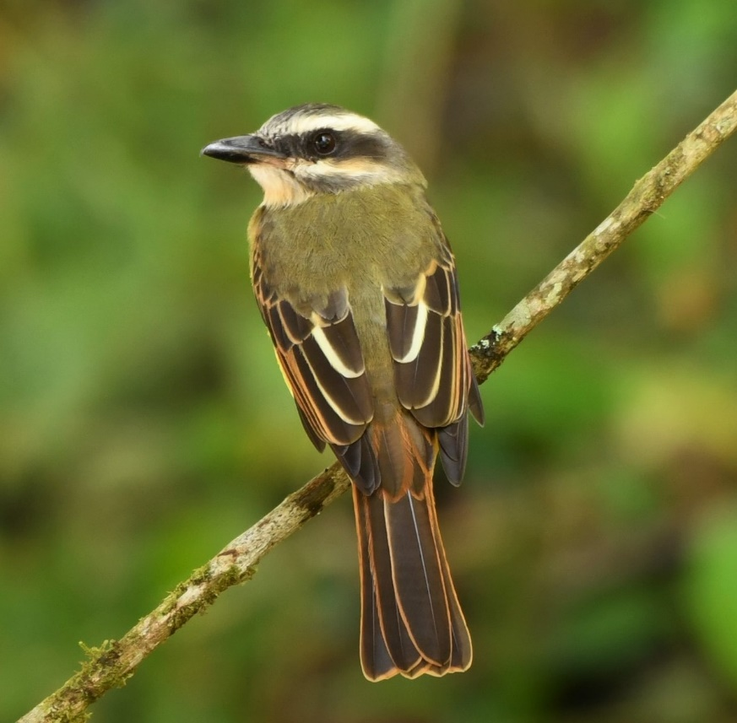
Golden-crowned flycatcher, Myiodynastes chrysocephalus 1 TAN (photo – 18 Nov. 2018 Callyn Yorke)
Streaked flycatcher, Myiodynastes maculatus 1 TAN
Boat-billed flycatcher, Megarynchus pitangua 1 RS
Tropical kingbird, Tyrannus melancholicus 1 TAN

Cotingas
Order: Passeriformes Family: Cotingidae
The cotingas are birds of forests or forest edges in tropical South America. Comparatively little is known about this diverse group, although all have broad bills with hooked tips, rounded wings, and strong legs. The males of many of the species are brightly colored or decorated with plumes or wattles. Twenty-eight species have been recorded in Ecuador.
Green-and-black fruiteater, Pipreola riefferii 1 roadside forest, TAN-SJM.
Red-crested cotinga, Ampelion rubrocristata 1 SJQ, 1 YAN

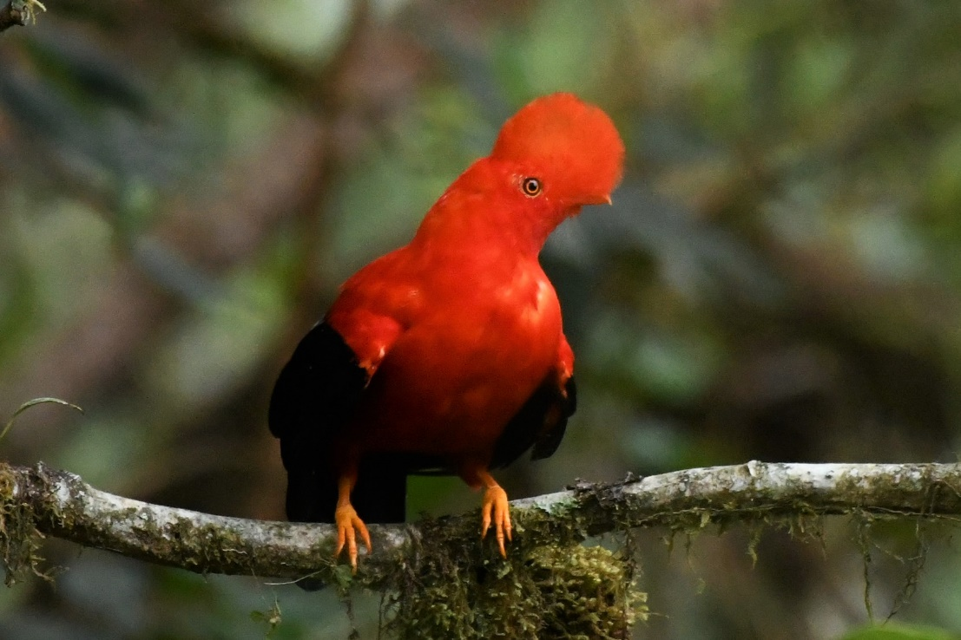Andean cock-of-the-rock, Rupicola peruviana 10, gregarious, vocal on lek, PAZ (photo – 22 Nov. 2018 Callyn Yorke)

Manakins
Order: Passeriformes Family: Pipridae
The manakins are a family of subtropical and tropical mainland Central and South America and Trinidad and Tobago. They are compact forest birds, the males typically being brightly colored, although the females of most species are duller and usually green-plumaged. Manakins feed on small fruits, berries, and insects. Sixteen species have been recorded in Ecuador.
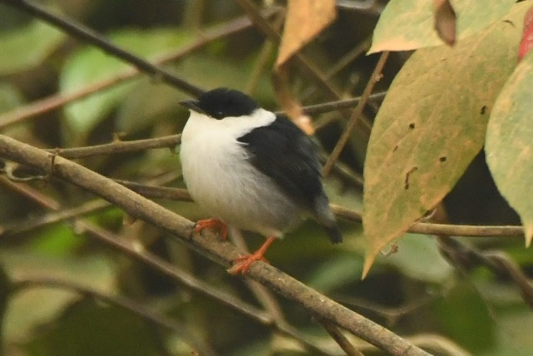
White-bearded manakin, Manacus manacus 1 RS (photo – 21 Nov. 2018 Callyn Yorke)

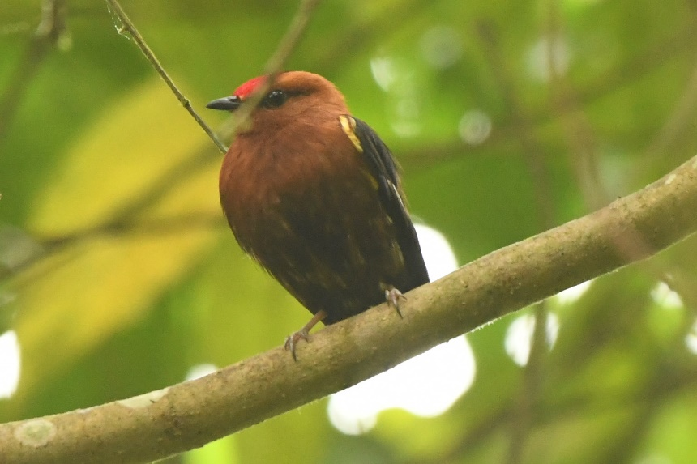
Club-winged manakin, Machaeropterus deliciosus 1 SJM (photo – 20 Nov, 2018 Callyn Yorke)

Tityras and allies
Order: Passeriformes Family: Tityridae
Tityridae are suboscine passerine birds found in forest and woodland in the Neotropics. The species in this family were formerly spread over the families Tyrannidae, Pipridae, and Cotingidae. They are small to medium-sized birds. They do not have the sophisticated vocal capabilities of the songbirds. Most, but not all, have plain coloring. Twenty-two species have been recorded in Ecuador.
Masked tityra, Tityra semifasciata 1 TAN
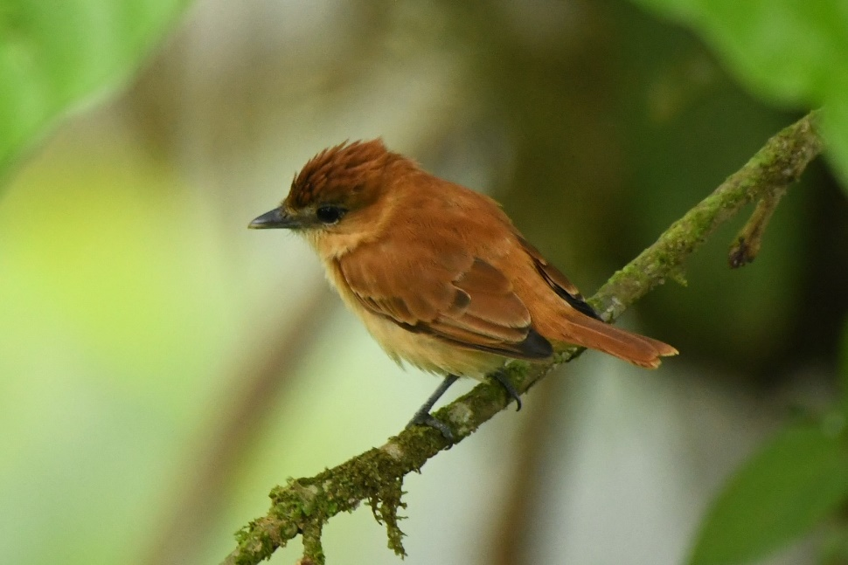Cinnamon becard, Pachyramphus cinnamomeus 1 active in middle of forest understory SJM (photo – 20 Nov. 2018 Callyn Yorke)
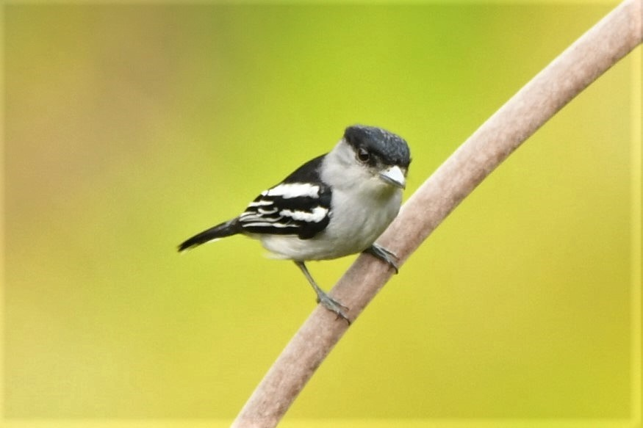
Black-and-white becard, Pachyramphus albogriseus 1 TAN (photo – 18 Nov. 2018 Callyn Yorke)
One-colored becard, Pachyramphus homochrous 1 SJM

Vireos
Order: Passeriformes Family: Vireonidae
The vireos are a group of small to medium-sized passerine birds restricted to the New World. They are typically greenish in color and resemble wood warblers apart from their heavier bills. Fifteen species have been recorded in Ecuador.
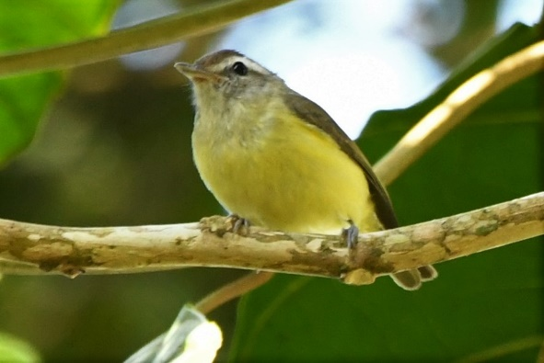
Brown-capped vireo, Vireo leucophrys 1 TAN; 1 PAZ (photo – 22 Nov. 2018 PAZ Callyn Yorke)
Red-eyed vireo, Vireo olivaceus 2 TAN

Swallows
Order: Passeriformes Family: Hirundinidae
The family Hirundinidae is adapted to aerial feeding. They have a slender streamlined body, long pointed wings, and a short bill with a wide gape. The feet are adapted to perching rather than walking, and the front toes are partially joined at the base. Eighteen species have been recorded in Ecuador.
Blue-and-white swallow, Pygochelidon cyanoleuca 10 nesting under eaves, TAN; 6 SJQ
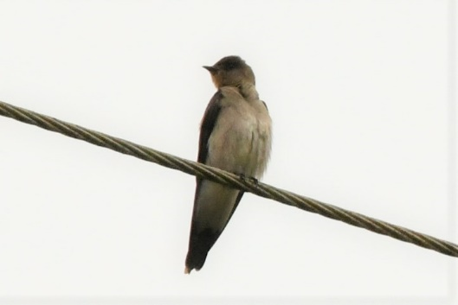
Southern rough-winged swallow Stelgidopteryx ruficollis 1 RS (photo – 21 Nov. 2018 Callyn Yorke)
Wrens
Order: Passeriformes Family: Troglodytidae
The wrens are mainly small and inconspicuous except for their loud songs. These birds have short wings and thin down-turned bills. Several species often hold their tails upright. All are insectivorous. Twenty-five species have been recorded in Ecuador.
House wren, Troglodytes aedon 1, vocal, TAN; 1 RS
Mountain wren, Troglodytes solstitialis 1, voca,l TAN
Sedge wren, Cistothorus platensis 1 secretive in low scrub, SJQ
Plain-tailed wren, Pheugopedius euophrys 2 YAN
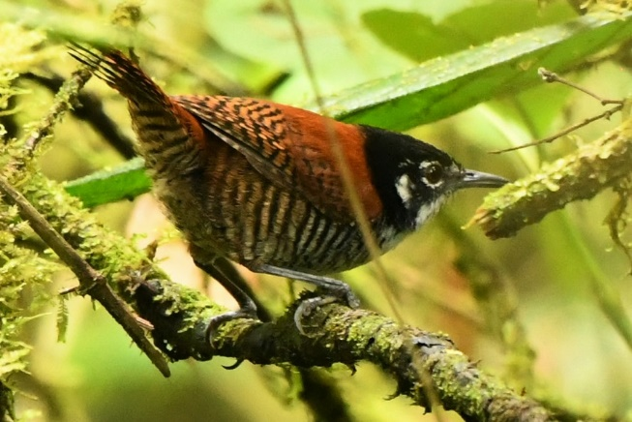
Bay wren, Cantorchilus nigricapillus 1 vocal- unseen, SJM (photo -20 Nov. 2018 Callyn Yorke)
Gray-breasted wood-wren, Henicorhina leucophrys 1 NM

Dippers
Order: Passeriformes Family: Cinclidae
Dippers are a group of perching birds whose habitat includes aquatic environments in the Americas, Europe and Asia. They are named for their bobbing or dipping movements. One species has been recorded in Ecuador.
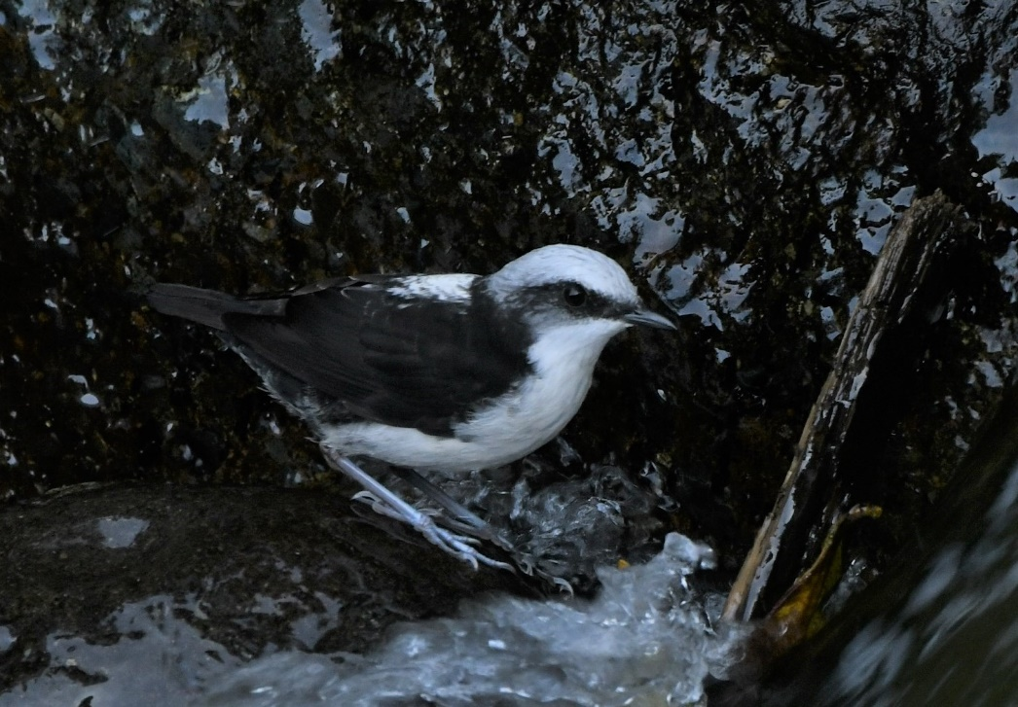White-capped dipper, Cinclus leucocephalus 2 in swift, rocky streams PAZ; 2 NM (photo – 22 Nov. 2018 PAZ Callyn Yorke)

Thrushes and allies
Order: Passeriformes Family: Turdidae
The thrushes are a group of passerine birds that occur mainly in the Old World. They are plump, soft plumaged, small to medium-sized insectivores or sometimes omnivores, often feeding on the ground. Many have attractive songs. Twenty-two species have been recorded in Ecuador.
Andean solitaire, Myadestes ralloides 1 TAN
Swainson's thrush, Catharus ustulatus 1 TAN
Ecuadorian thrush, Turdus maculirostris 1 TAN; 1 forest edge, TAN-SJM

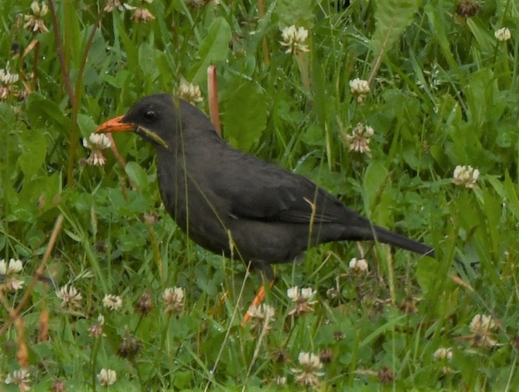
Great thrush, Turdus fuscater 5 SJQ; 6 YAN (photo- 16 Nov. 2018 SJQ Callyn Yorke)
Glossy-black Thrush Turdus serranus 1 STA

Tanagers and allies
Order: Passeriformes Family: Thraupidae
The tanagers are a large group of small to medium-sized passerine birds restricted to the New World, mainly in the tropics. Many species are brightly colored. They are seed eaters, but their preference tends towards fruit and nectar. Most have short, rounded wings. One hundred seventy-three species have been recorded in Ecuador.
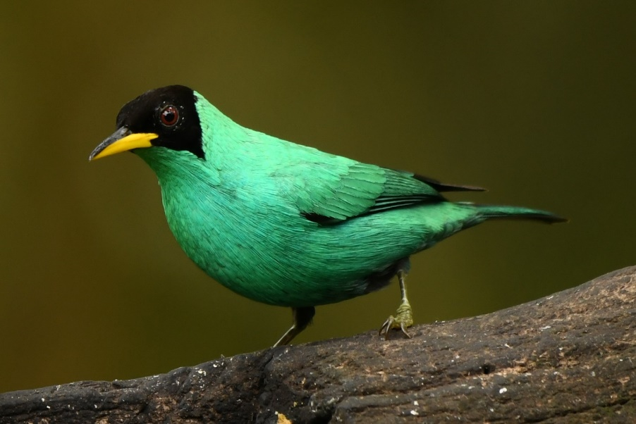Green honeycreeper, Chlorophanes spiza 2 SJM (photo – 19 Nov. 2018 Callyn Yorke)

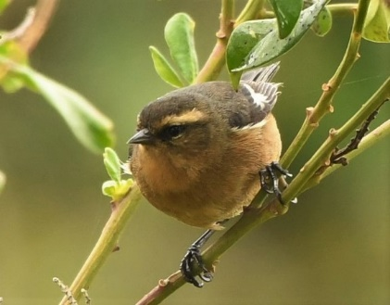
Cinereous conebill, Conirostrum cinereum 1 SJQ (photo – 16 Nov. 2018 Callyn Yorke)

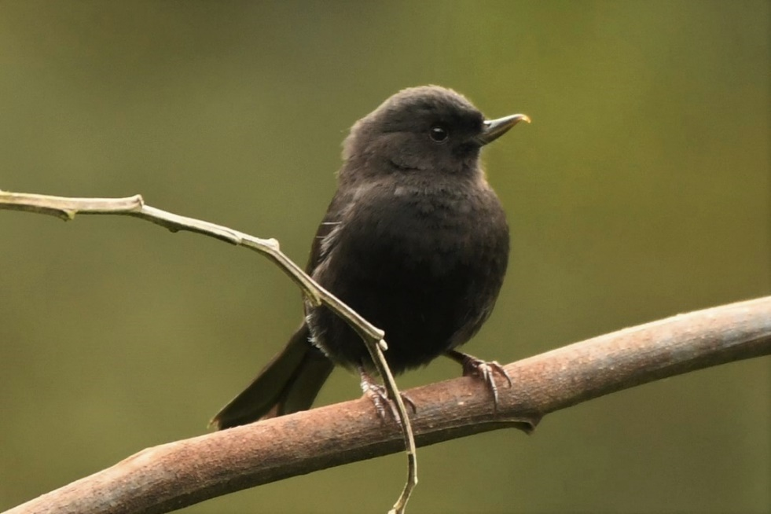
Black flowerpiercer, Diglossa humeralis 1 SJQ (photo – 16 Nov. 2018 Callyn Yorke)

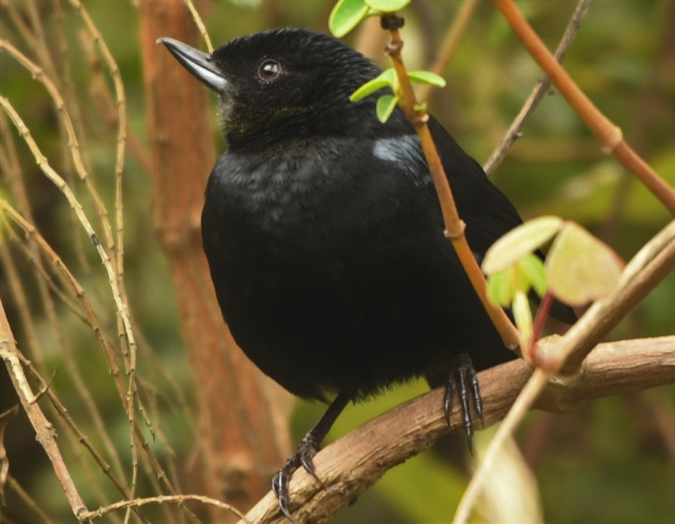
Glossy Flowerpiercer, Diglossa sp. 1 YAN (photo – 17 Nov. 2018 Callyn Yorke)
White-sided flowerpiercer, Diglossa albilatera 1 YAN

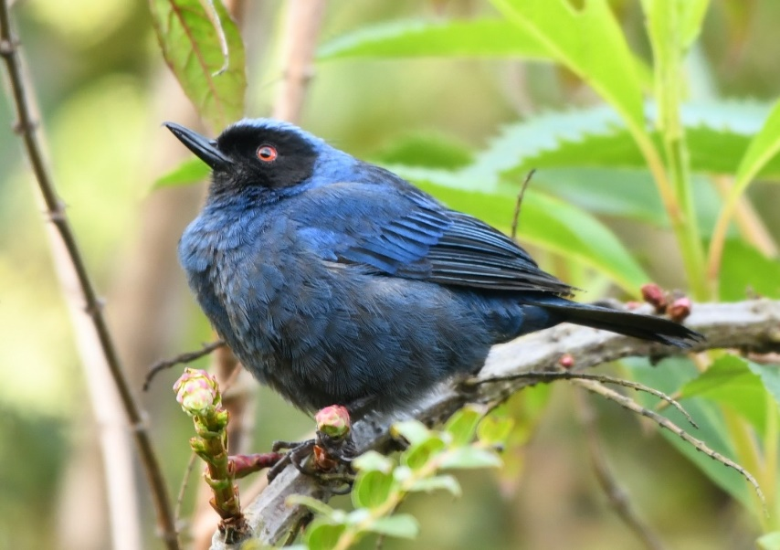
Masked flowerpiercer, Diglossa cyanea 1 JNP (photo – 17 Nov. 2018 Callyn Yorke)

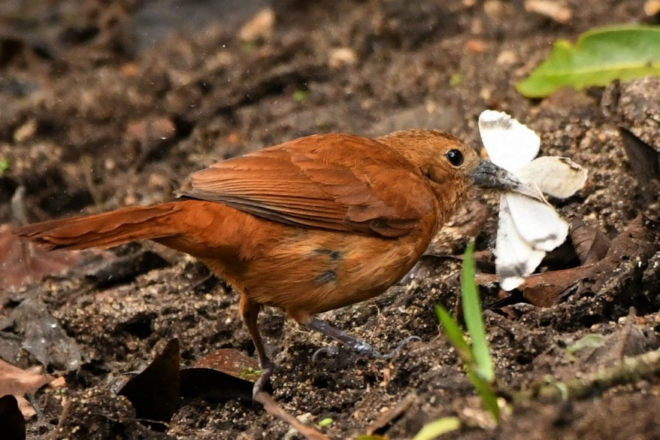
White-lined tanager, Tachyphonus rufus 2 (m,f) feeding at moth trap, TAN (photo – fem. 24 Nov. 2018 Callyn Yorke)

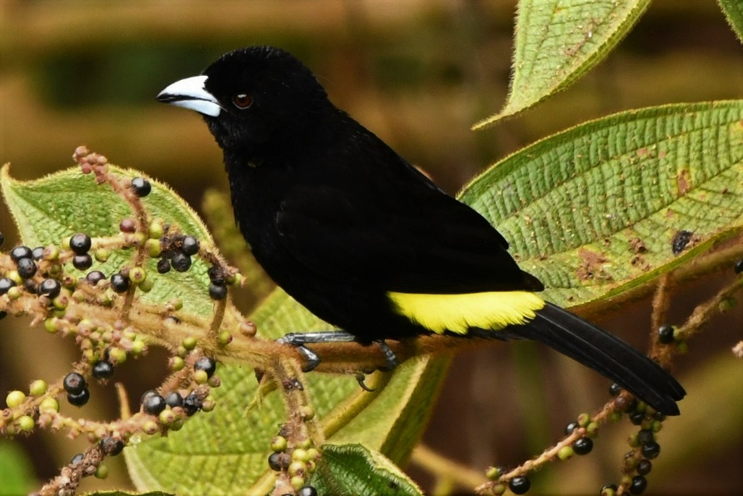
Lemon-rumped tanager, Ramphocelus icteronotus) 4 (m,f) gregarious TAN (photo – male, 23 Nov. 2018 Callyn Yorke)

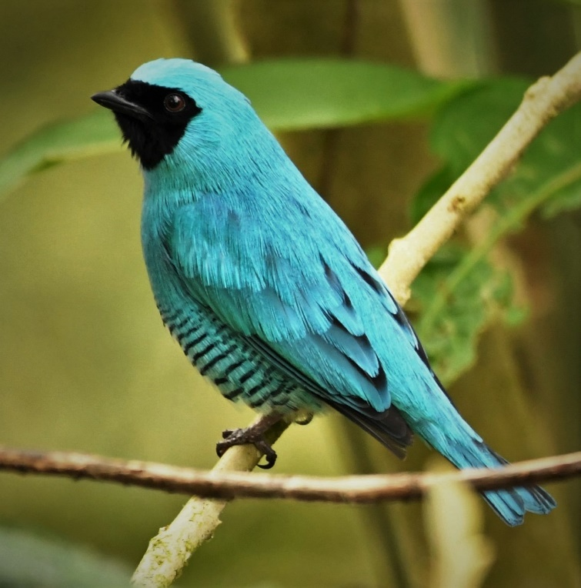
Swallow tanager, Tersina viridis 1 TAN (photo – 21 Nov. 2018 Callyn Yorke)
Variable seedeater, Sporophila corvina 2 TAN
Yellow-bellied seedeater, Sporophila nigricollis 1 TAN
Paramo seedeater Catamenia homachroa 2 JNP

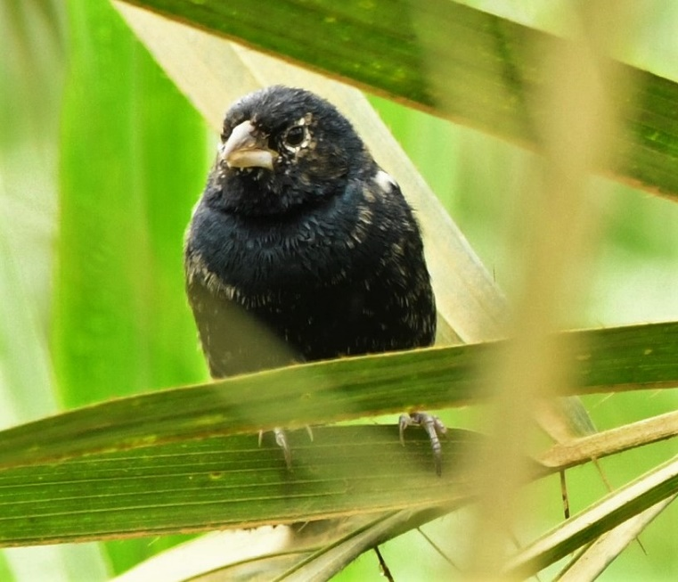
Blue-black grassquit, Volatinia jacarina 2 RS (photo – 21 Nov. 2018 Callyn Yorke)
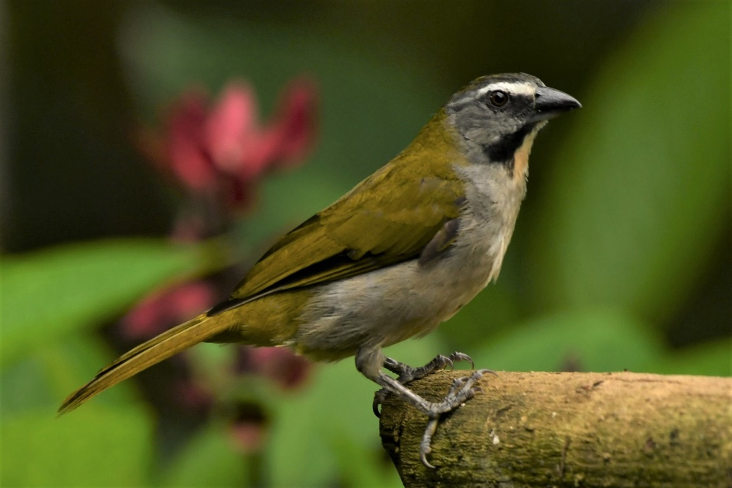
Buff-throated saltator, Saltator maximus 1 RS; 1 TAN (photo – 19 Nov. 2018 Callyn Yorke)
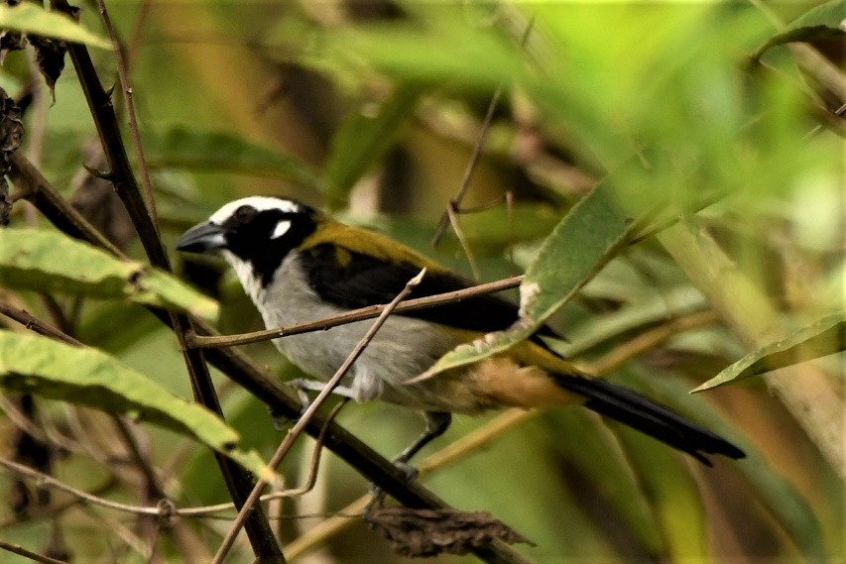
Black-winged saltator, Saltator atripennis 1 TAN (photo – 23 Nov. 2018 Callyn Yorke)
Streaked Saltator Saltator striatipectus 1 JNP

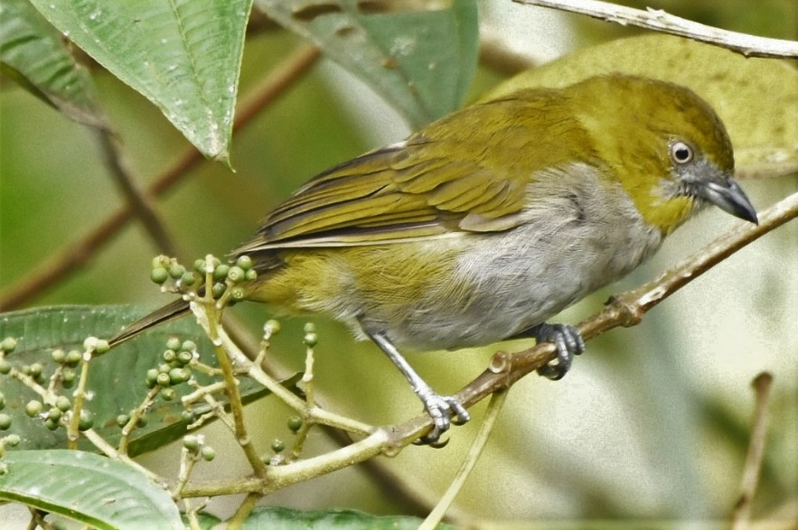
Superciliaried hemispingus, Thlypopsis superciliaris 1 NM (photo -20 Nov. 2018 Callyn Yorke)
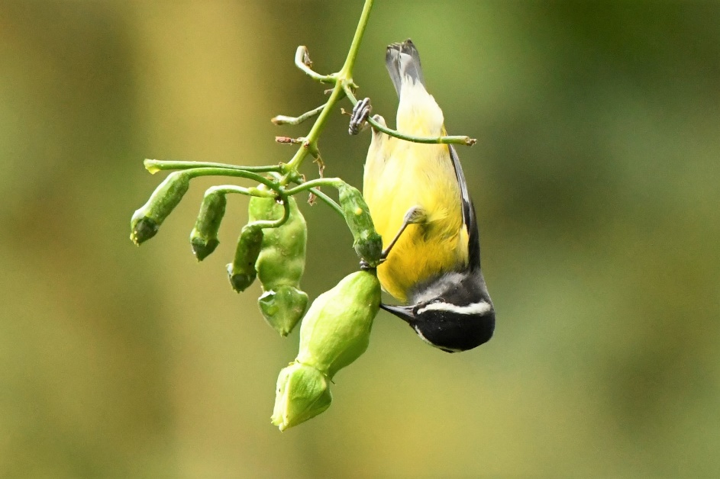
Bananaquit, Coereba flaveola 1 SJM (photo –20 Nov. 2018 Callyn Yorke)
Yellow-throated tanager, Iridosornis analis 1 SJM
Golden-crowned tanager, Iridosornis rufivertex

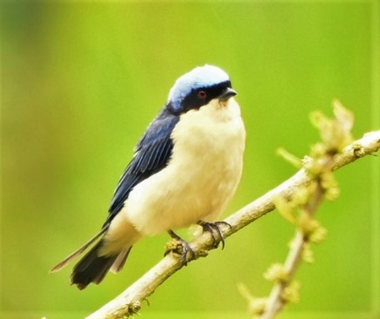
Fawn-breasted tanager, Pipraeidea melanonota 1 TAN (photo – 18 Nov. 2018 Callyn Yorke)

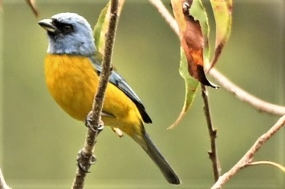
Blue-and-yellow tanager, Pipraeidea bonariensis 1 SJQ (photo -16 Nov. 2018 Callyn Yorke)

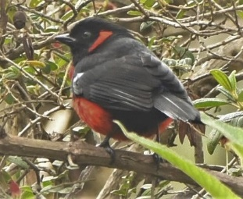
Scarlet-bellied mountain-tanager, Anisognathus igniventris 1 SJQ (photo -17 Nov. 2018 Callyn Yorke)

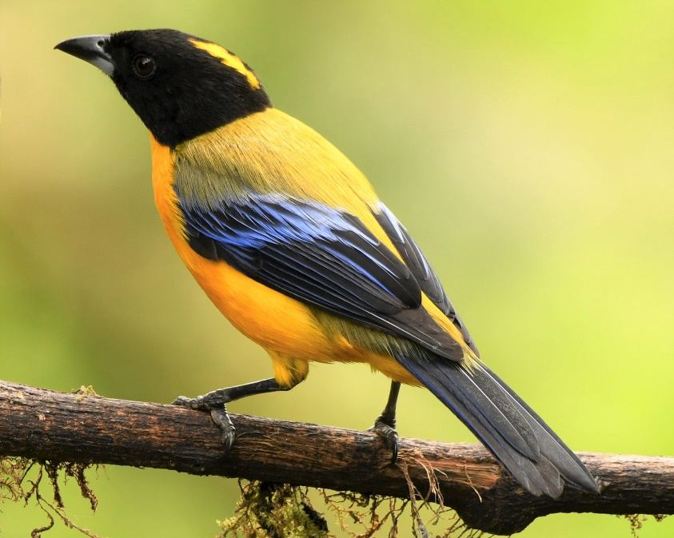
Blue-winged mountain-tanager, Anisognathus somptuosus 2 YAN-NM; 1 PAZ; 1 TAN; 1 STA (photo – 19 Nov. 2018 STA Callyn Yorke)

Black-chinned mountain-tanager, Anisognathus notabilis 1 STA
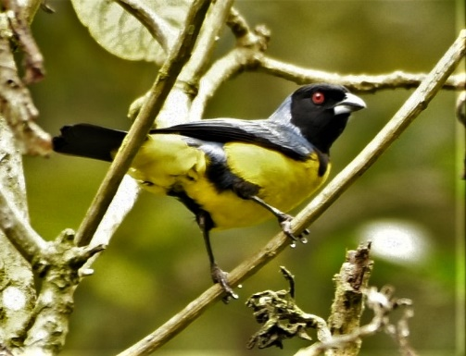
Hooded mountain-tanager, Buthraupis montana 1 YAN-NM (photo – 18 Nov. 2018 Callyn Yorke)

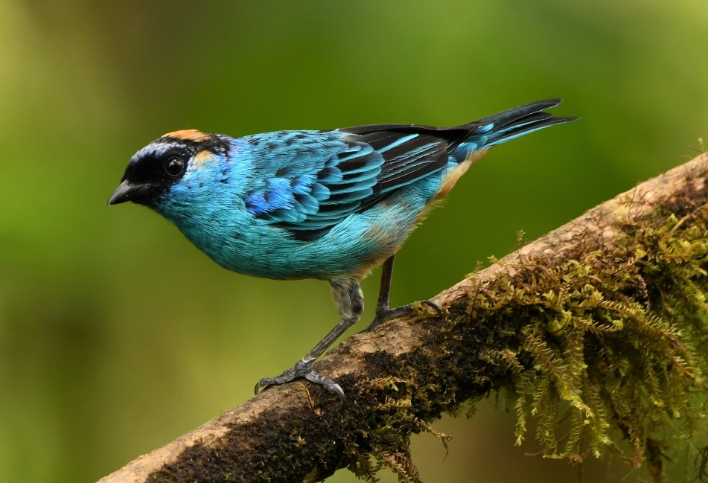Golden-naped tanager, Chalcothraupis ruficervix 1 TAN (photo – 19 Nov. 2018 Callyn Yorke)
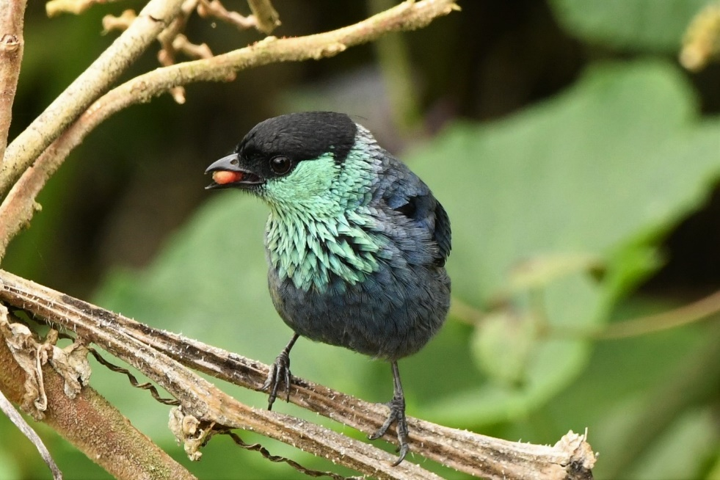
Black-capped tanager, Stilpnia heinei 1 TAN (photo – 23 Nov. 2018 Callyn Yorke)
Scrub tanager, Stilpnia vitriolina 2 JNP
Blue-necked tanager, Stilpnia cyanicollis 1 RS

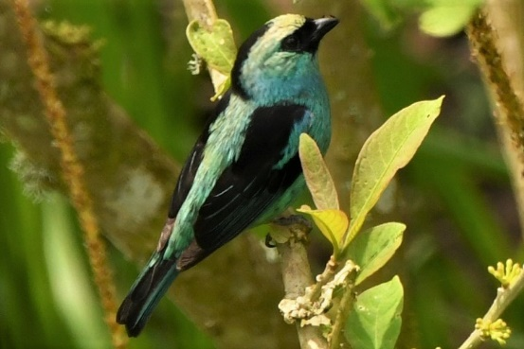
Metallic-green tanager, Tangara labradorides 1 PAZ; 1 TAN (photo – 24 Nov. 2018 Callyn Yorke)
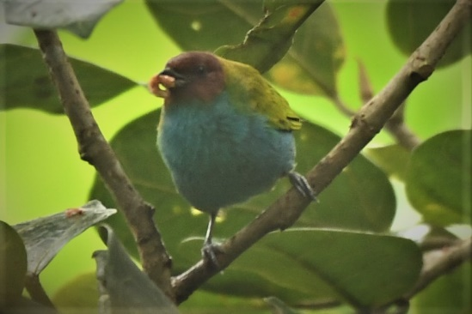
Bay-headed tanager, Tangara gyrola 1 SJM (photo – 24 Nov. 2018 Callyn Yorke)

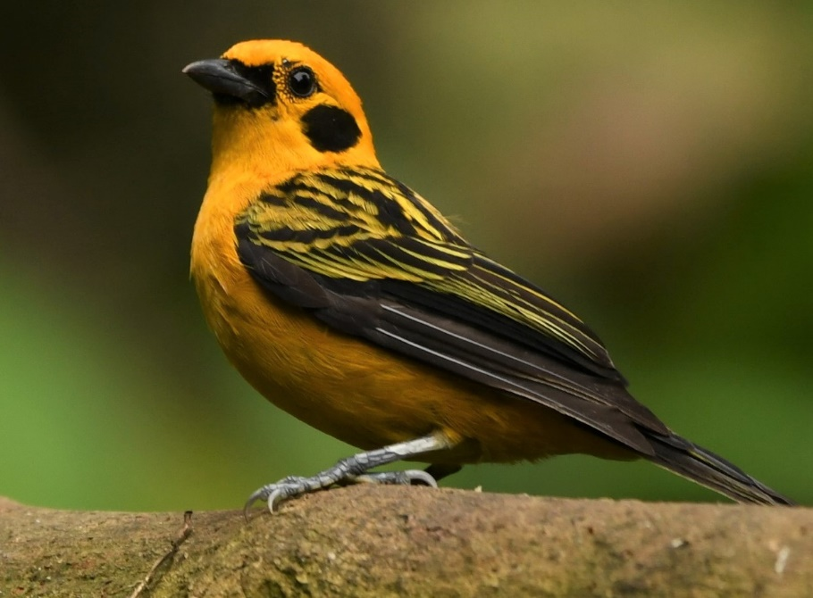
Golden tanager, Tangara arthus 1 TAN (photo – 19 Nov. 2018 Callyn Yorke)
Emerald tanager, Tangara florida 1 SJM

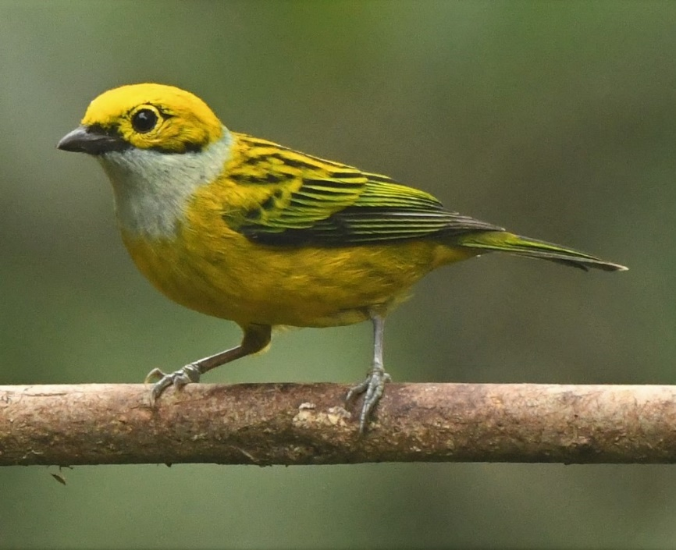
Silver-throated tanager, Tangara icterocephala 1 SJM (photo – 20 Nov. 2018 Callyn Yorke)

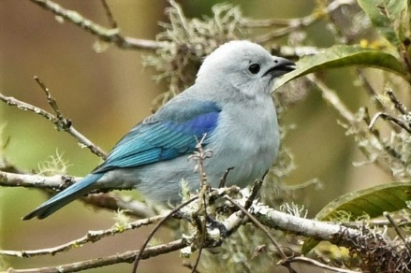
Blue-gray tanager, Thraupis episcopus 1 JNP; 1 TAN (photo – 23 Nov. 2018 TAN Callyn Yorke)

Palm tanager, Thraupis palmarum 1 TAN; 4 SJM

New World sparrows
Order: Passeriformes Family: Emberizidae
Most of the species are known as sparrows, but these birds are not closely related to the Old World sparrows which are in the family Passeridae. Many of these have distinctive head patterns. Twenty-seven species have been recorded in Ecuador.
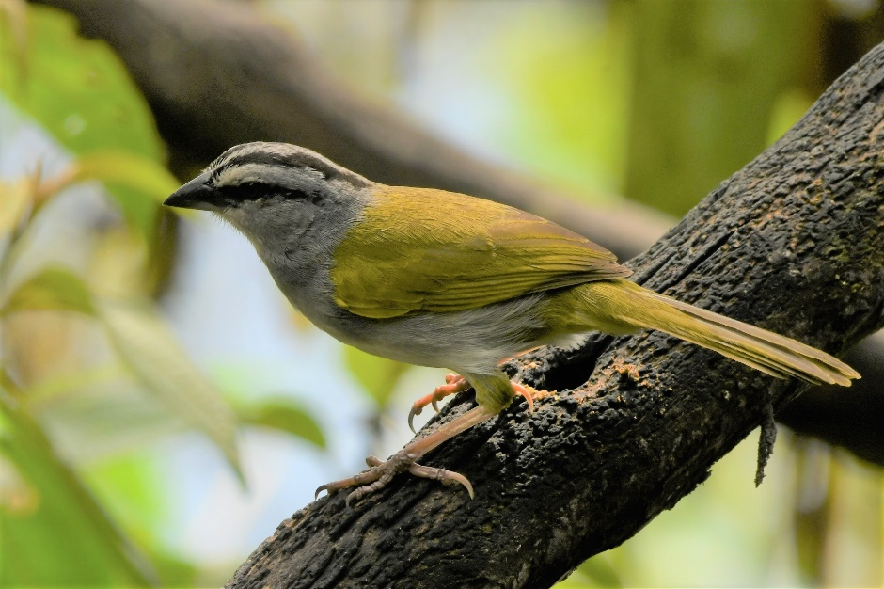
Black-striped sparrow, Arremonops conirostris 1 STA (photo – 19 Nov. 2018 Callyn Yorke)

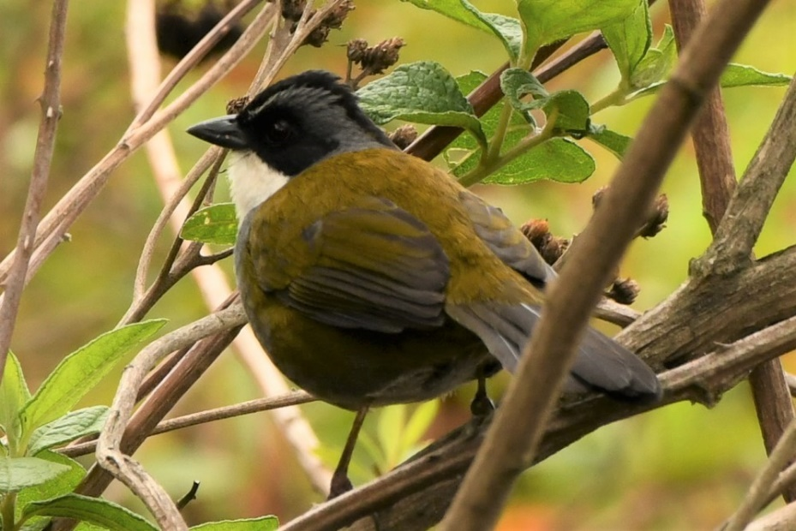
Gray-browed brushfinch, Arremon assimilis 2 SJQ (photo -16 Nov. 2018 Callyn Yorke)

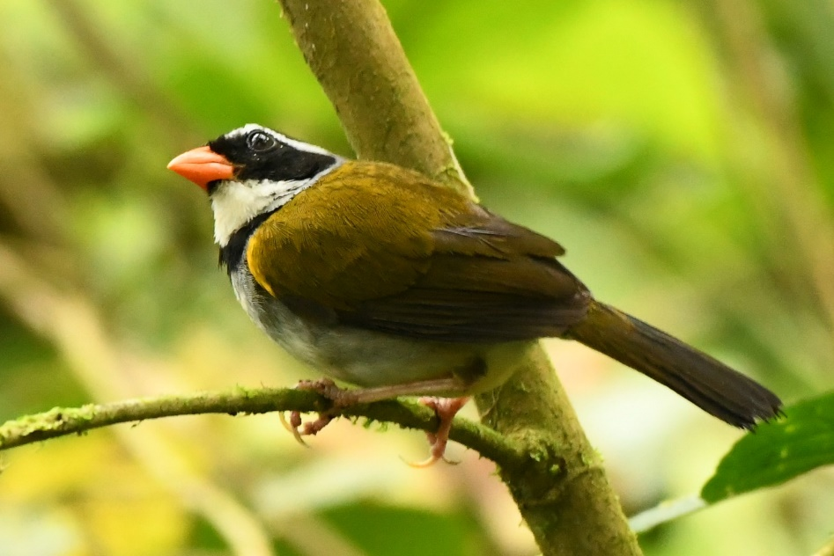Orange-billed sparrow, Arremon aurantiirostris 2 SJM (photo – 20 Nov. 2018 Callyn Yorke)

Chestnut-capped brushfinch, Arremon brunneinucha 1 TAN (photo – 24 Nov. 2018)
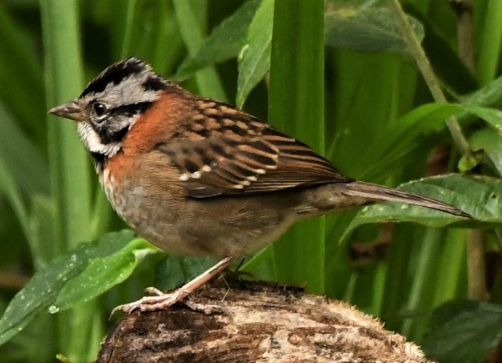Rufous-collared sparrow, Zonotrichia capensis 2 UBQ (photo -24 Nov. 2018 Callyn Yorke)
Tricolored brushfinch, Atlapetes tricolor 1(?) TAN
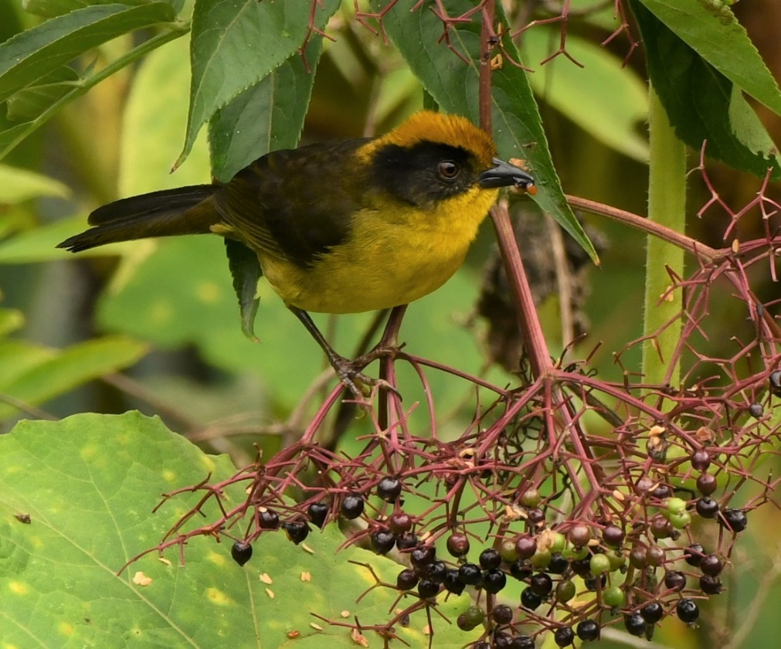Yellow-breasted brushfinch, Atlapetes latinuchus 1 YAN; 1 at moth trap TAN (photo – 18 Nov. 2018 TAN Callyn Yorke)
White-winged brushfinch, Atlapetes leucopterus 1 TAN

Cardinals and allies
Order: Passeriformes Family: Cardinalidae
The cardinals are a family of robust seed-eating birds with strong bills. They are typically associated with open woodland. The sexes usually have distinct plumages. Eighteen species have been recorded in Ecuador.
Summer tanager, Piranga rubra 1 TAN

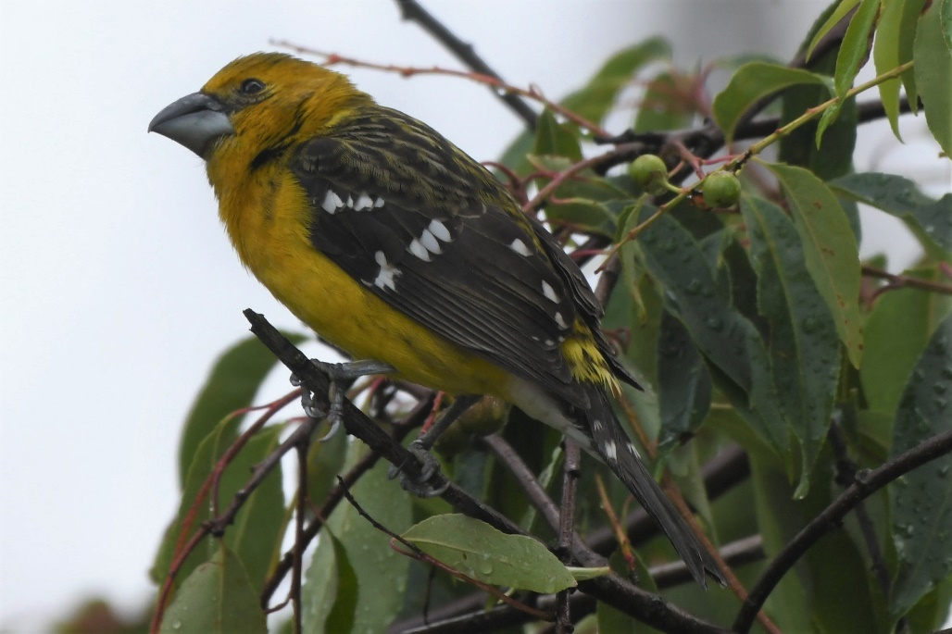
Golden grosbeak, Pheucticus chrysogaster 1 SJQ; 1 STA (photo -15 Nov. SJQ Callyn Yorke)

New World warblers
Order: Passeriformes Family: Parulidae
The New World warblers are a group of small, often colorful, passerine birds restricted to the New World. Most are arboreal, but some are terrestrial. Most members of this family are insectivores. Thirty-two species have been recorded in Ecuador.
Tropical parula, Setophaga pitiayumi 1 (m) TAN

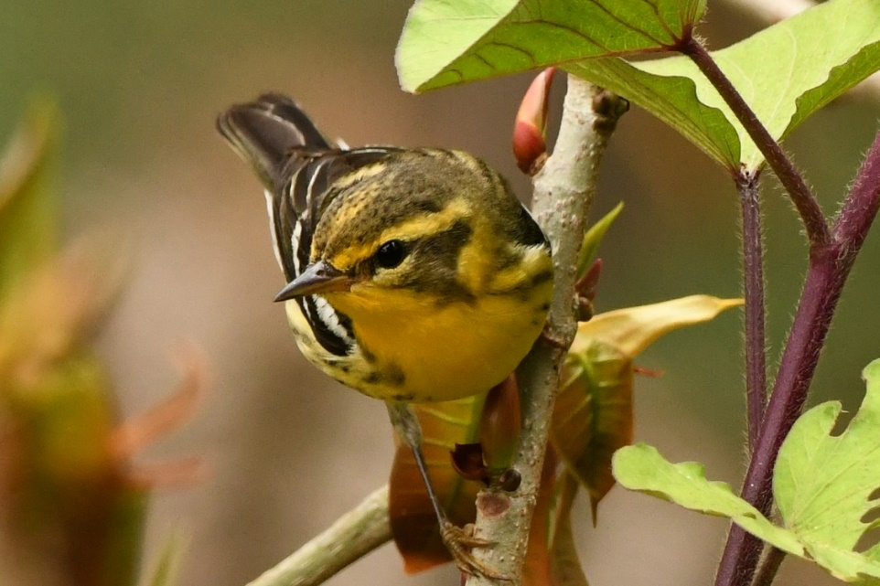
Blackburnian warbler, Setophaga fusca 2 UBQ (photo – 23 Nov. 2018 SJT Callyn Yorke)
Black-crested warbler, Myiothlypis nigrocristata 1 YAN
Buff-rumped warbler, Myiothlypis fulvicauda 1 SJM
Russet-crowned warbler, Myiothlypis coronata 1 TAN

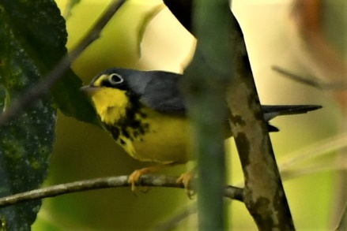
Canada warbler, Cardellina canadensis 1 TAN (photo – 18 Nov. 2018 Callyn Yorke)

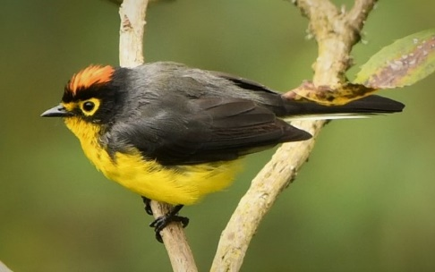
Spectacled redstart, Myioborus melanocephalus 1 YAN (photo -17 Nov. 2018 Callyn Yorke)
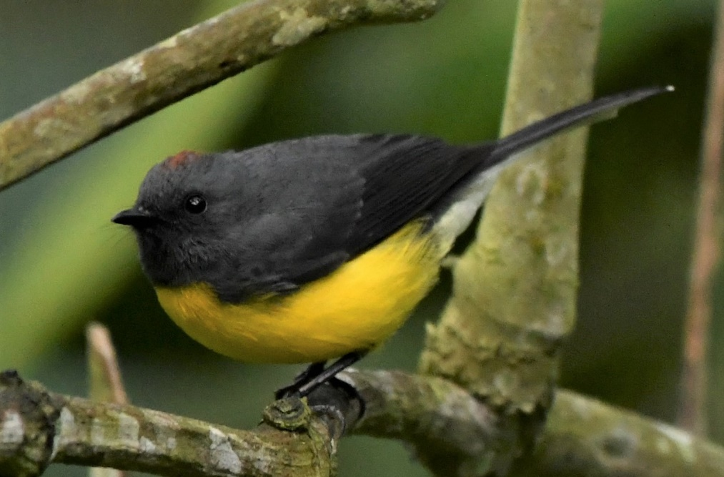
Slate-throated redstart, Myioborus mineatus 1 SJQ (photo – 24 Nov. 2018 Callyn Yorke)

Troupials and allies
Order: Passeriformes Family: Icteridae
The icterids are a group of small to medium-sized, often colorful, passerine birds restricted to the New World which include the grackles, New World blackbirds, and New World orioles. Most species have black as the predominant plumage color, often enlivened by yellow, orange, or red. Thirty species have been recorded in Ecuador
Gray-billed cacique, Amblycercus holosericeus 1 RS

Finches, euphonias, and allies
Order: Passeriformes Family: Fringillidae
Finches are seed-eating passerine birds that are small to moderately large and have a strong beak, usually conical and in some species very large. All have twelve tail feathers and nine primaries. These birds have a bouncing flight with alternating bouts of flapping and gliding on closed wings, and most sing well. Nineteen species have been recorded in Ecuador.
Hooded siskin, Spinus magellanicus 1 JNP
Yellow-bellied siskin, Spinus xanthogastrus 1 RS
Thick-billed euphonia, Euphonia laniirostris 1 TAN
Golden-rumped euphonia, Euphonia cyanocephala 2 (m,f) JNP

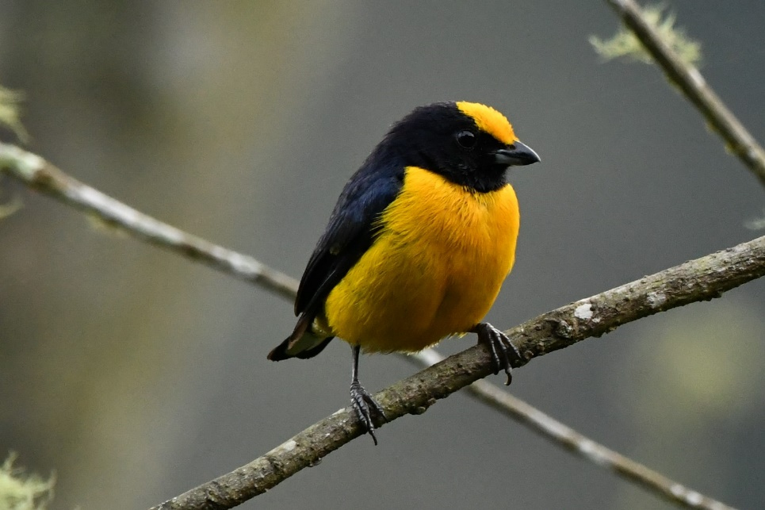
Orange-bellied euphonia, Euphonia xanthogaster 2 (m,f) taking small fruits in tree TAN (photo – 24 Nov. 2018 Callyn Yorke)

